2019 - 2020

Project Supervisor

Dr.Zeeshan Shafi Khan

Submitted By

Abdullah Al Khadeer



**Instant Paperless Services Management System for a University**

Thesis Report

***Instant Paperless Services Management System for a University***

|  |
| --- |
| ***Submitted by*** |
| *Abdullah Abdulaziz Al khadeer* |

|  |  |
| --- | --- |
| ***Examiners :*** | ***Signature*** |
|  |  |
|  |  |

|  |  |
| --- | --- |
| ***Supervisor :*** | ***Signature*** |
| **Dr. Zeeshan Shafi Khan**  (*Head of Computer Science Department)* |  |

|  |
| --- |
| ***Head of Department*** |
|  |

***Abstract***

*Currently in most of the universities, communication in the hierarchy is performed through papers. Papers are transferred from bottom and needs signatures of every higher authority until it reaches to the decision making authority. This paper based system brings several shortcomings like wastage of resources, slow decision making process, late responses, loss of documents, management of documents etc. To replace this paper based system, in this project a paperless services management system will be developed in which most of the services will be provided to the faculty members instantly by using automatic systems. Members can ask for academic services, HR services, financial services, IT services etc. All these services can be obtained by using this system. C# and SQL server will be used as tool to develop this system.*

# 1

# **CHAPTER** 1

Introduction

­­

This chapter will introduce the main ideas, goals and requirements for this project.

*Instant Paperless Services Management System (***IPSMS***)* is an application thatprovide a good environment for faculty members and management members that help them to speed up the processes of some of the importance processes such as: equalization for students and holidays request from employees of university

* 1. **Objectives**

In the following list are some of the objectives and benefit from building the IPSMS:

Aim of the work is to :

* Fasten the decision making process and save time
* Utilize the resources properly
* Prevent the loss of documents and enhance management of documents
* Obtain up-to-date reports with one click
* Efficient transfer and communication
  1. **Scope**

In this project I am preparing a software for credit transfer and faculty services for the Mustaqabal University. I followed the process of Mustaqbal University to approve different types of faculty requests as well as credit transfer cases. Only the selected services are developed and implemented.

**1.4 Methodology**

I used in this project the prototype model which is used in software development life cycle in which the process of the system can be seen as a flowing. In prototype model before designing the actual development, prototypes are developed evaluated, updated until customer is satisfied. After customer approval of prototype, main development will start.

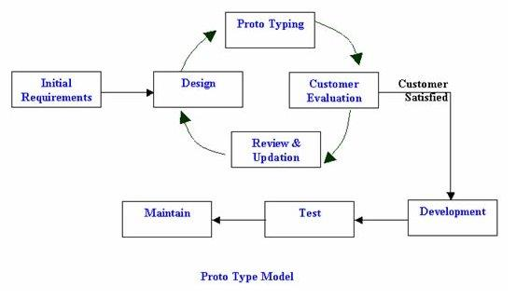

*Figure 1.1 Prototype Model [1]*

The basic idea in Prototype model is that instead of freezing the requirements before a design or coding can proceed, a throwaway prototype is built to understand the requirements. This prototype is developed based on the currently known requirements. Prototype model is a software development model. By using this prototype, the client can get an “actual feel” of the system, since the interactions with prototype can enable the client to better understand the requirements of the desired system. Prototyping is an attractive idea for complicated and large systems for which there is no manual process or existing system to help determining the requirements.

**1.4.1 Requirements**

The requirements for this project has been collected from students and instructors. For equalization I take interviews with some students and ask them about current way that using for equalization for students and a employees requests so the **IPSMS** will be completely fit and meet their requirements. Students need to know the updates for the processes of equalization and convert the paper work into technical. Faculty members also need to know where their requests and know the update about it by application

**1.4.2 Testing and Debugging**

In this stage I will use multiple methods for testing and evaluating.

**1.4.2.1 White-Box Testing:** (also known as clear box testing, glass box testing, transparent box testing, and structural testing) is a method of testing software that tests internal structures or workings of an application, as opposed to its functionality (i.e. black-box testing). In white-box testing an internal perspective of the system, as well as programming skills, are used to design test cases. The tester chooses inputs to exercise paths through the code and determine the appropriate outputs. This is analogous to testing nodes in a circuit, e.g. in-

circuit testing (ICT). White-box testing can be applied at the unit, integration and system levels of the software testing process. Although traditional testers tended to think of white- box testing as being done at the unit level, it is used for integration and system testing more frequently today. It can test paths within a unit, paths between units during integration, and between subsystems during a system–level test. Though this method of test design can uncover many errors or problems, it has the potential to miss unimplemented parts of the specification or missing requirements. *[6]*

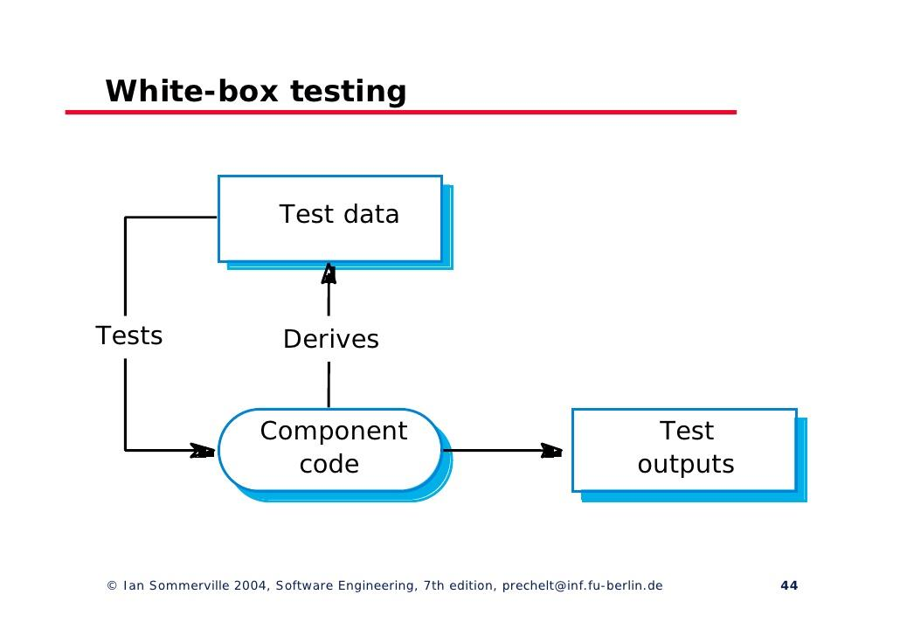

*Figure 1.2 White-box Testing Process*

**1.4.2.2 Black-Box Testing:** is a method of software testing that examines the functionality of an application without peering into its internal structures or workings. This method of test can be applied virtually to every level of software testing: unit, integration, system and acceptance. It typically comprises most if not all higher level testing, but can also dominate unit testing as well. *[7]*

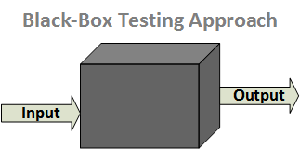

*Figure 1.3 Black-box Testing Approach*

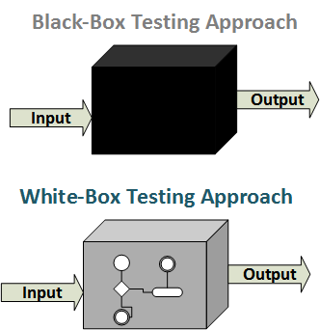

*Figure 1.4 Black And White -box Testing Approach*

**1.4.2.3 Acceptance Testing**

formal testing with respect to user needs, requirements, and business processes conducted to determine whether a system satisfies the acceptance criteria and to enable the user, customers or other authorized entity to determine whether or not to accept the system. Acceptance testing is also known as user acceptance testing (UAT), end-user testing, operational acceptance testing (OAT) or field (acceptance) testing. *[8]*

**1.4.3 Deploying**

The project will be installed on a computer that supports the technologies that was used to built it. After that the project will be available to users to access the application and benefit from it.

**1.5 Assumption**

There is a compatible operating system where the **IPSMS** is installed and that allow users to access the **IPSMS**.

•  All users have internet access.

•  All users have username and password.

•  All users have installed the application

**1.6 Modules**

**- Registration:**

Admin will be able to register their accounts as students or teachers or.

**- Login:**

Registered users will be able to login using their username and passwords.

**- Report a Salary or Financial:**

The employees will be able to report any financial issues.

**- Approve or Deny requests:**

Whom has properties to accept or deny request they will be able to receive request through the application and then decide such as: HOD receive a request from faculty member for short leave.

**- Report an IT problems:**

The employees will be able to report any issues related to IT support.

**- Apply for full leave:**

The employees will be able to ask for full leave.

**- Apply for short leave:**

The employees will be able to ask for short leave.

**- Request Exit and Entry Visa:**

The faculty members and the HOD will be able to ask to Exit and Entry Visa through the application.

**- Apply for re-new Iqama:**

The faculty members and the HOD will be able to ask to re-new Iqama through the application.

**- Upload equalization**

Through the application the student affairs will be able to Upload the equalization and then take the approve from the HoD, Credit Transfer, and dean.

# 2

# **CHAPTER** 2

Related Work

* 1. **A close up of a sign

     Description automatically generatedSAP ( System Analysis Program Development )**

SAP Human Capital Management (SAP HCM) is an important module in SAP. It is also known as SAP Human Resource Management System (SAP HRMS) or SAP Human Resource (HR).

*Figure 2.1 SAP Services*

*Figure 2.2 SAP HR Services*

### **2.1.1 SAP HR consist of the following modules**

* Organizational Management
* Personnel Administration
* Time Management
* Payroll Accounting
* Travel Management.

an example from SAP HR:

**2.1.2 Work Schedules**

Work schedules are used to indicate an employee’s planned working time, daily working hours, weekly work pattern and weekly days off. The below picture is an example of a work schedule

*Figure 2.3 Work Schedules*

**2.2 Sage 100**

Sage 100 has many modules in their program they made it for Save time, money, and the environment by using the paperless office capabilities provided to you in Sage 100 ERP (formerly Sage ERP MAS 90 and 200). Improve communications and save postage by efficiently emailing and faxing documents to your customers, prospects, vendors, resellers, and employees in the same office or remote locations.

**2.2.1 Sage 100 consist of the following modules:**

### Accounting and Finance

### E- Business/E-Commerce

### Business Intelligence and Integration Tools

### Distribution

### Resource and Project Management

### Manufacturing

*Figure 2.4 Home Page*

*Figure 2.5 Sage Inventory Advisor*

**2.3 GLOBODOX**

**GLOBODOX** is a document management software that enables medium or large organizations to paperless, securely manage and share documents. Extremely easy to deploy and use, **GLOBODOX** is used by many companies around the world. It features an integrated set of tools that let you scan, index, search, secure and share documents and keep an audit trail.

**2.3.1 GLOBODOX consist of the following modules:**

* Draft Documents
* Windows Active Directory Integration
* Web Client
* Workflow
* GLOBODOX REST API
* Document Retention

*Figure 2.6 Checks Screen.*

*Figure 2.7 Invoices Screen*

**2.4 formitize** (Quote, Invoice & Payments )

By this program you can create Quotes or estimates in seconds using one off detail or

accessing your Line Items for speed and accuracy. Send as finished PDF with photos,

signatures and attachments. Instantly see the status of all of your Quotes and Invoices. Filter by Paid and Outstanding and simply swipe to follow up with a call, email or SMS.

*Figure 2.8 Signatures Screen*

**As well as** view the Current Status in Real time. Instantly see the status of all of your Quotes and invoices. Filter by Paid and Outstanding and simply swipe to follow up with a call, email or SMS.

*Figure 2.9 Invoices Screen*

**2.4.1 formitize consist of the following modules:**

* Create Quotes in seconds
* View the Current Status in Real time

## Take Payment & Send Receipt

* Automated Quote Follow Up

* 1. **Odoo Documents**

With Odoo Documents, you can easily share, send, categorize, and archive scanned documents. You can also generate business documents such as vendor bills, tasks, and product sheets for manufacturing as well as get documents e-signed, and have them sent directly back.

**2.5.1 Odoo consist of the following modules:**

* Email gateway

#### Assign with teams and clients

* e-signed documents

*Figure 2.10 Documents Screen*

*Figure 2.11 Signature Screen*

* 1. A close up of a sign

     Description automatically generated**SutiDMS**

**SutiDMS** is an online document management software solution that lets any businesses organize, manage, share, and communicate critical information. A robust document management system that can meet the needs of organizations of any size. **SutiDMS** comes with integrated modules that help anyone with team collaboration, workflow management, and approvals. No download or installation require, work online anywhere, anytime.

**2.6.1 SutiDMS consist of the following modules:**

* Document library
* Manage documents and multi-level folders
* Document version control
* Document event log history
* Merge multiple documents into single PDFs
* Bulk file uploads
* OCR document capture
* File routing and approval
* Customizable dashboard

*Figure 2.12 Documents Library*

* 1. **OpenDocMan**

OpenDocMan is a free, web-based, open source document management system (DMS) written in PHP designed to comply with ISO 17025 and OIE standard for document management

**2.7.1 OpenDocMan consist of the following modules:**

* Add any file type to the system
* Not FTP required. Upload directly from your browser.
* Meta data fields for each file
* Assign a department/category to each file
* Create custom document properties to match your companies needs
* Revision history

*Figure 2.13 Documents upload screen*

**2.8 LogicalDOC**

What is the EDMS? An electronic document management system is a software system designed to organize and store documents of different kinds or forms.

It is a particular type of document management system – a general form of document management system designed to help with the organization and storage of digital or paper documents by its users.

Although the EDMS is specially designed to handle digital documents, it is sometimes used for paper documents also. The software can likewise handle digital scanned copies of original paper documents.

**2.8.1 LogicalDOC consist of the following modules:**

* Share and Collaborate Documents in the right place

### Shared Server ( You can install LogicalDOC on a server that is accessible to all the workstations in your organization )

### LogicalDOC Cloud ( This solution allow the organization to use LogicalDOC on servers cloud storage )

### Stand-alone

# 3

# **CHAPTER** 3

Software Design

For system design in this project, I used Unified Modeling Language (UML).

Software design is a cycle to change client necessities into some appropriate structure, which helps the developer in programming coding and usage.

For surveying client prerequisites, a SRS (Software Requirement Specification) archive is made while for coding and execution, there is a need of more explicit and nitty gritty necessities in programming terms. The yield of this cycle can straightforwardly be utilized into usage in programming dialects.

Software design is the initial phase in SDLC (Software Design Life Cycle), which moves the fixation from issue space to arrangement area. It attempts to determine how to satisfy the prerequisites referenced in SRS.

At whatever point a software developer begins taking a shot at another undertaking, clearly he would need to begin scripting the code immediately. Notwithstanding what his ability is over the software are, on the off chance that he constructs programming without spreading out an arrangement for it, at that point he may be building a home without setting a solid establishment. All things considered, regardless of how solid the structure cycle and utilization of assets are, the house will fall, likewise, without a central design, the software is additionally going to crash. No one truly wills to release the exertion futile, simply out of a senseless mix-up of not setting an arrangement for it, isn't that so? Indeed, that is the place programming configuration becomes an integral factor, a system that permits basic programming cycles to be improved in a specific way

**3.2 SDLC (Software development life cycle)**

Software development life cycle (SDLC) is a progression of stages that give a typical comprehension of the software building measure. How the software will be acknowledged and created from the business comprehension and necessities elicitation stage to change over these business thoughts and prerequisites into capacities and highlights until its utilization and activity to accomplish the business needs. The great programming designer ought to have enough information on the best way to pick the SDLC model dependent on the venture setting and the business prerequisites.

Hence, it might be needed to pick the right SDLC model as indicated by the particular concerns and necessities of the venture to guarantee its prosperity

*Figure 3.1 SDLC Shape*

* + 1. **Prototype Module**

Prototype is defined as the way toward developing a working replication of an item or framework that must be built. It offers a little scope copy of the finished result and is utilized for getting client input as depicted beneath:

*Figure 3.2 Prototyping Model Shape*

**3.3 UML (Unified Modeling Language)**

**Unified Modeling Language** **(UML)** is a universally useful displaying language. The primary point of UML is to characterize a standard method to picture the manner in which a framework has been planned. It is very like plans utilized in different fields of building.

UML isn't a programming language, it is somewhat a visual language. We use UML charts to depict the conduct and structure of a framework. UML helps programming specialists, finance managers and framework planners with displaying, plan and investigation. The Article The board Gathering (OMG) embraced Bound together Demonstrating Language as a norm in 1997. Its been overseen by OMG from that point onward. Global Association for Normalization (ISO) distributed UML as an affirmed norm in 2005. UML has been reconsidered throughout the long term and is explored occasionally.

* Complex applications need coordinated effort and arranging from numerous groups and thus require a reasonable and succinct approach to impart among them.
* Money managers don't understand code. So UML gets fundamental to speak with non developers basic prerequisites, functionalities and cycles of the framework.
* A great deal of time is spared down the line when groups can imagine measures, client associations and static structure of the framework.

**UML** is connected with **object oriented** design and analysis. UML utilizes components and structures relationship between them to frame charts. Charts in UML can be comprehensively delegated:

**Structural Diagrams** – Catch static perspectives or structure of a framework.

Structural Diagrams include: Component Diagrams, Object Diagrams, Class Diagrams and Deployment Diagrams

**Behavior Diagrams** – Catch dynamic perspectives or conduct of the framework. Behavior Diagrams include: Use Case Diagrams, Sequence Diagrams, Activity Diagrams and Class Diagrams.

* + 1. **Figure of UML**
* Use Case Diagram
* Sequence Diagram
* Activity Diagram

**3.3.1.1 Use Case Diagram**

An UML use case diagram is the essential type of system/software requirements for another software program immature. Use cases determine the normal conduct (what), and not the specific technique for getting it going (how). Use cases once indicated can be meant both literary and visual portrayal (for example use case graph). A key idea of utilization case demonstrating is that it encourages us plan a framework from the end client's viewpoint. It is a successful strategy for conveying framework conduct in the client's terms by determining all remotely obvious system conduct.

*Figure 3.3 UML Use Case Diagram Symbols*

**3.3.1.2 Sequence Diagram**

UML Sequence Diagrams are cooperation diagrams that detail how activities are done. They catch the connection between objects with regards to a joint effort. Succession Outlines are time center and they show the request for the connection outwardly by utilizing the vertical pivot of the diagram to speak to time what messages are sent and when.

*Figure 3.4 UML Sequence Diagram Symbols*

**3.3.1.3 Activity Diagram**

Activity diagram is another significant conduct diagram in UML outline to portray dynamic parts of the system. Activity diagram is basically a serious variant of flow chart that displaying the flow starting with one action then onto the next action.

*Figure 3.5 UML Activity Diagram Symbols*

**3.3.2 Figure of IPSMS UML**

* Use Case Diagram
* Sequence Diagram
* Activity Diagram
  + - 1. **Use Case Diagram**

*Figure 3.6 UML Use Case Diagram of Faculty member or Staff*

Figure shown what the staff and faculty members are able to do through the application.

*Figure 3.7 UML Use Case Diagram of Head Of Department.*

Figure shown what Head of Department able to do through the application:

Such as: receive a requests from faculty member for short leave and then approved and the request will automatically go to whom higher than HoD (Dean) and so on.

*Figure 3.8 UML Use Case Diagram of Student Affairs.*

Student Affairs are only able to upload equalization of the courses through the application and take the approve from the HOD and the dean through the application.

*Figure 3.9 UML Use Case Diagram of Dean.*

The deans can approve and reject only the requests that already approved from the head of department as well as equalization of the courses.

*Figure 3.10 UML Use Case Diagram of Admin.*

Admin can add users to the application so admin handle who can access to the application.

*Figure 3.11 UML Composite of Use Cases Diagram.*

The figure show the composite of uses cases.

**3.3.2.2 Sequence Diagrams**

*Figure 3.12 UML Sequence Diagram of Equalization .*

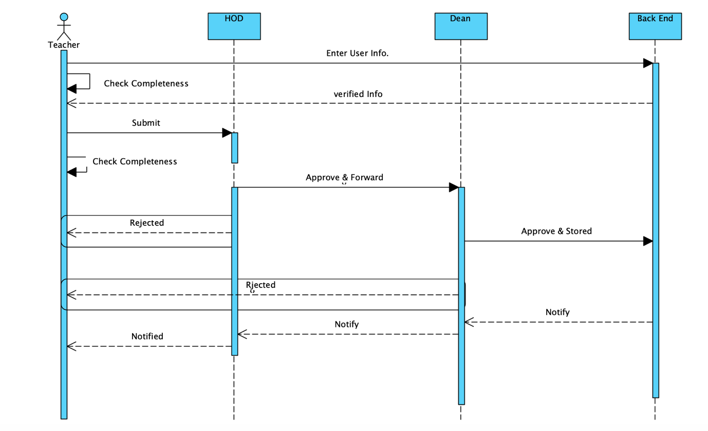This table show the apply equalization processes from credit transfer to whom responsible in the collage ( HoD, Dean,Student Affairs, Student ) in both status rejected or approve it.

*Figure 3.13 UML Sequence Diagram of apply short leave.*

This table shown the processes of approve or reject new short leave form that create it from staff or faculty members

* + - 1. **Activity Diagram**

*Figure 3.14 UML Activity Diagram of apply full leave.*

*Figure 3.15 UML Activity Diagram of Fill Equalization.*

*Figure 3.16 UML Activity Diagram of apply short leave.*

* 1. **Database Design**

**Database design** is the organization of data according to a database model. The designer determines what data must be stored and how the data elements interrelate. With this information, they can begin to fit the data to the database model. Database management system manages the data accordingly.

* + 1. **Tables of IPSMS**
* Full Leave
* Equalization
* Login
* Short Leave
* Student Affairs

**3.4.2.1 Full leave Table**

*Figure 3.17 Table of Full leave.*

Full leave table is stored the information that took from full leave form and stored. Status is changing depend on approvals or rejects among management members.

**3.4.2.2 Equalization**

*Figure 3.18 Table of Equalization.*

This table store first equalization create it from credit transfer and.

We need this table to store equalizations of students

**3.4.2.3 Login**

*Figure 3.19 Table of Login.*

Login table store all of the information that users need to be verified in the system. In **IPSMS** I use role to let the managements members differentiate among the users.

**3.4.2.4 Short Leave**

*Figure 3.20 Table of Short Leave.*

Short leave table is stored the information that took from full leave form and stored. Status is changing depend on approvals or rejects among management members.

**3.4.2.5 Student Affairs**

*Figure 3.21 Table of Student Affairs.*

There is an initial Equalization to see if the the student going to accept from the collage or not it’s the student affairs will create it and send it to dean

* 1. **Interfaces Design**

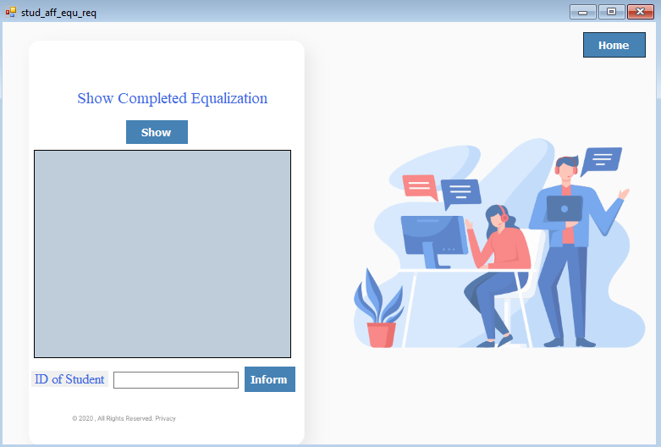

*Figure 3.22 Form of show completed equalization.*

This form showing completed equalization for student affairs and they can inform student by e-mail.

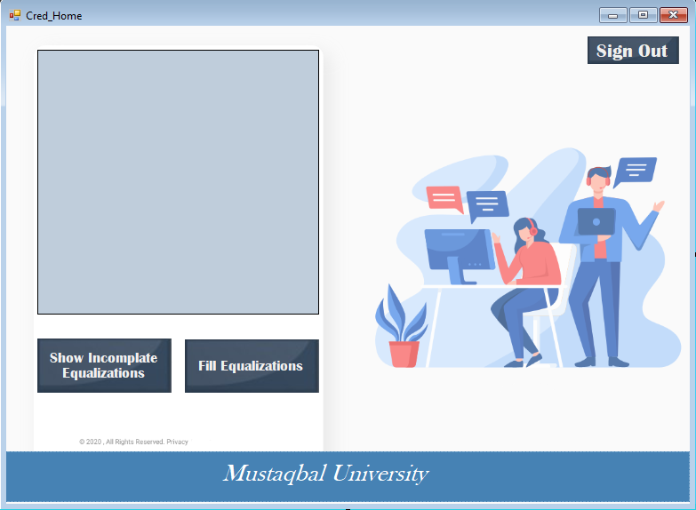

*Figure 3.23 Form of show incompleted equalization*

This form showing the incomplete equalization for credit transfer to be fill it.

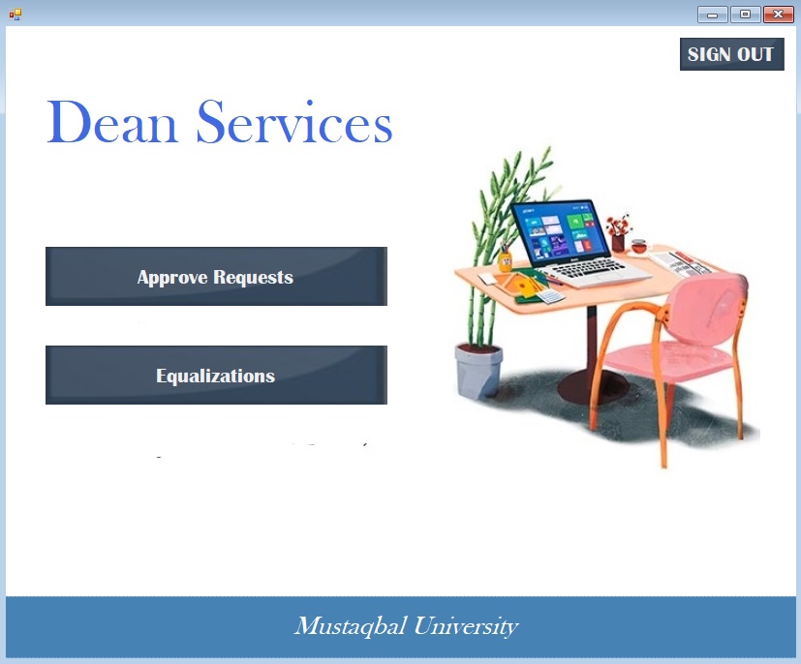

*Figure 3.24 Form of show Home of dean user.*

This form show the home of Dean and he can go to approve requests or equalizations

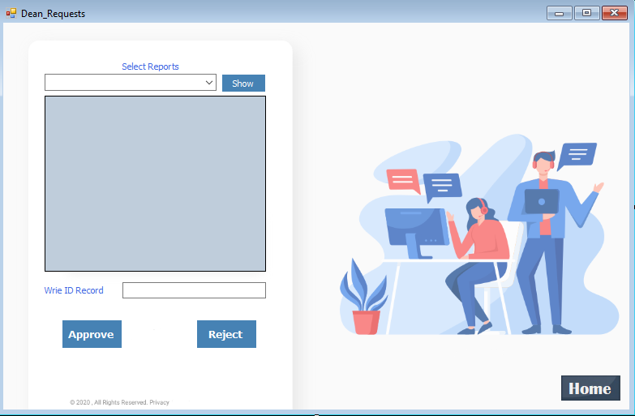

*Figure 3.25 Form of show Dean Requests.*

From this form the dean can approve the requests and send in only approve case in short leave or full leave e-mail to relevant department.

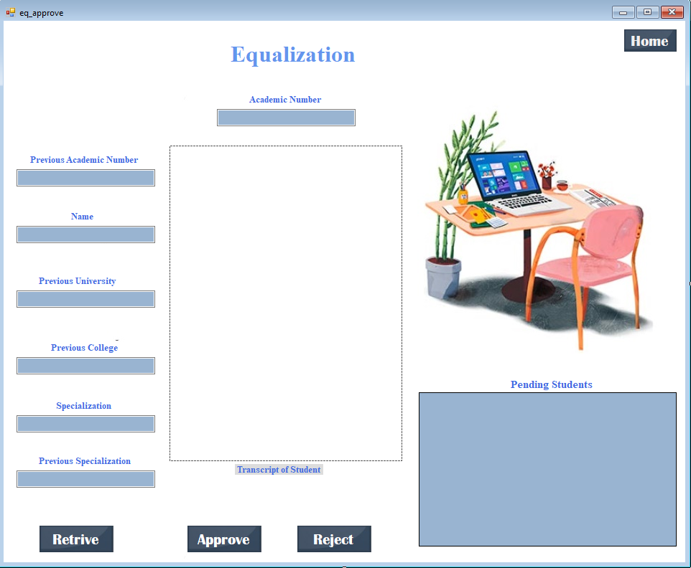

*Figure 3.26 Form of show equalizatios.*

Dean can retrieve the equalization that appear in student pending and approve it to be fill it from credit transfer.

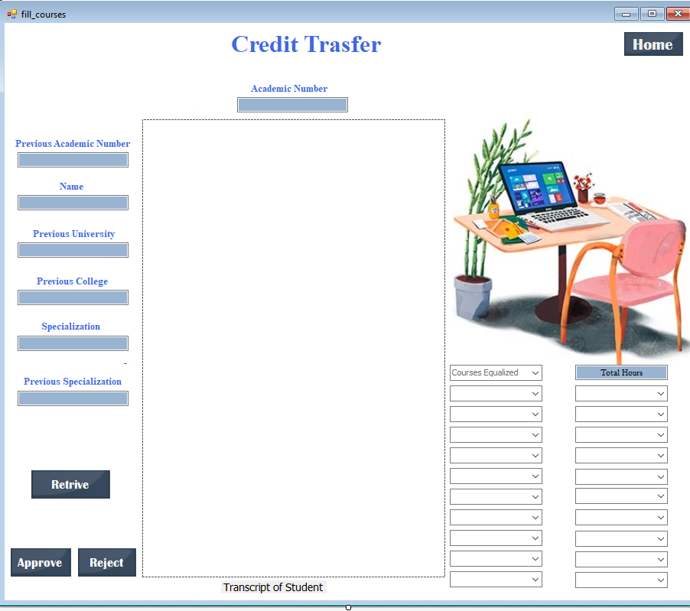

*Figure 3.27 Form of fill equalizations.*

Credit transfer can fully finish the equalization through this form and fill courses that equalized. To be approved from HoD.

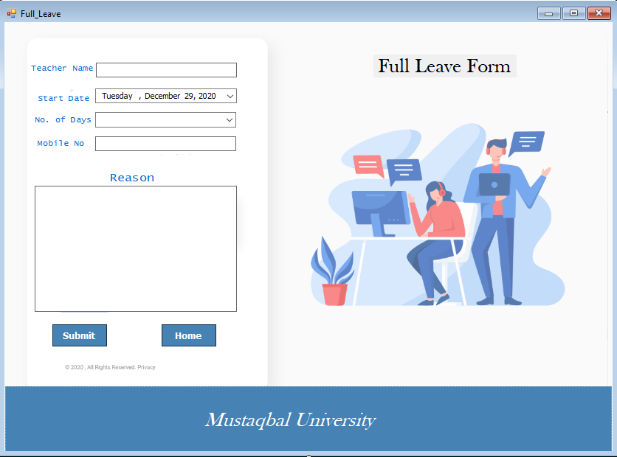

*Figure 3.28 Form of Full Leave..*

Teacher can apply full leave through this form to be approve from HoD and then the Dean.

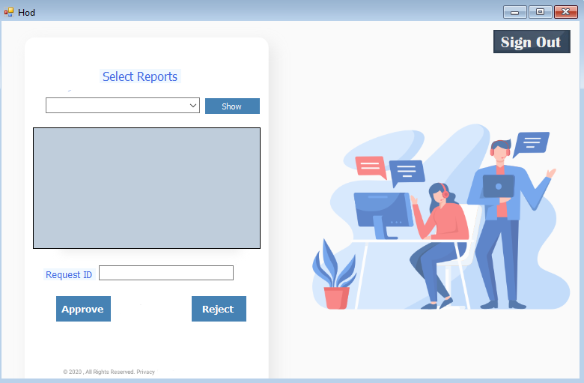

*Figure 3.29 Form of requests of HoD..*

Any requests will come through this form to be approve or rejected from HoD.

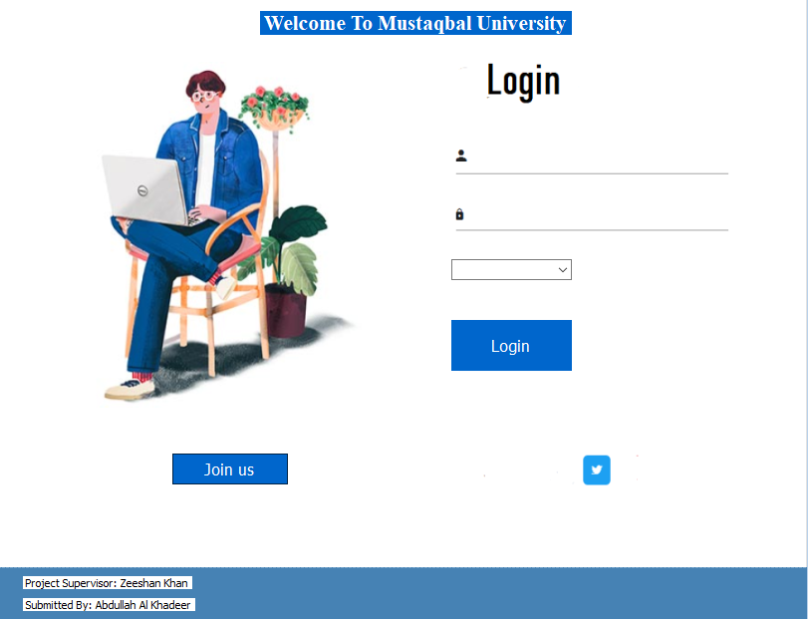

*Figure 3.30 Form of Sign in of users..*

Login Page of users

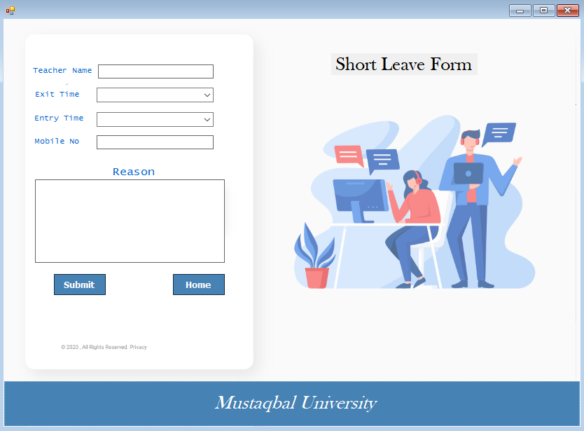

*Figure 3.31 Form of Short Leave..*

Teacher can apply full leave through this form to be approve from HoD and then the Dean.

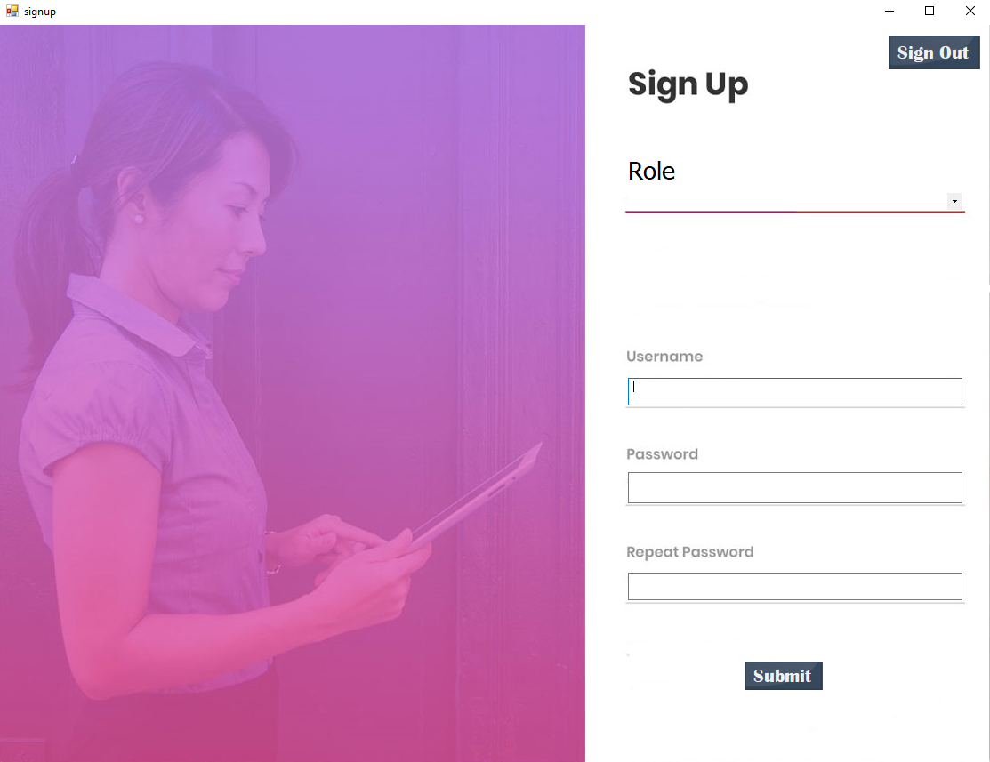

*Figure 3.32 Form of Sign up .*

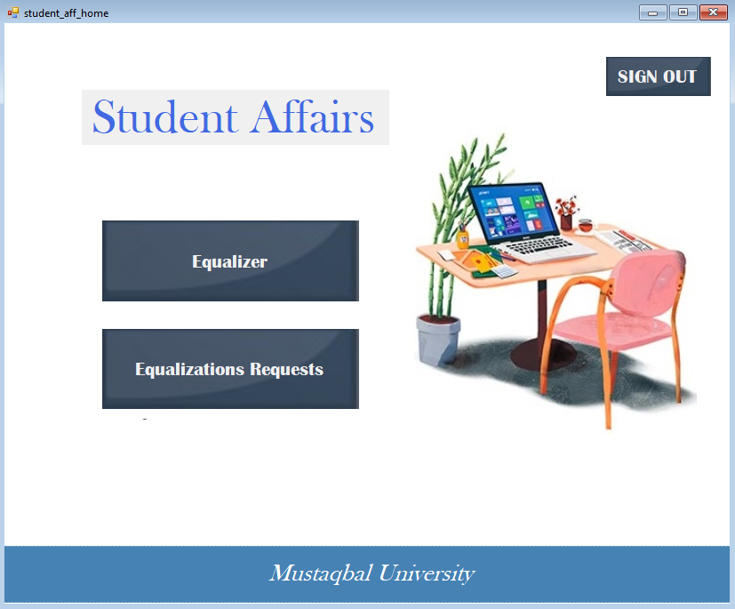

*Figure 3.32 Form of Student Affairs Home.*

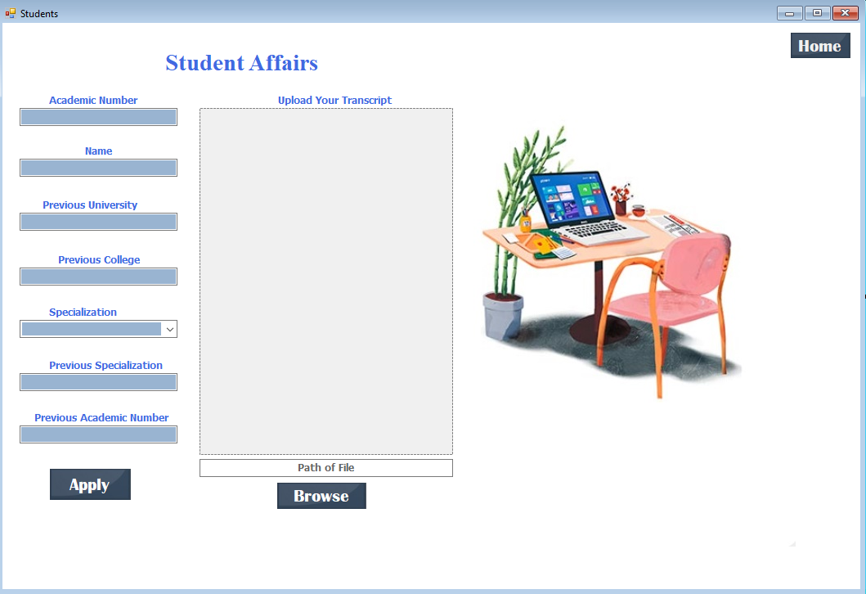Student affairs Home they can upload equalization through Equalizer and see the status o equalizations that already uploaded in equalizations requests.

*Figure 3.33 Form of upload equalization.*

Student Affair can upload the transcript of student through this form and information needed

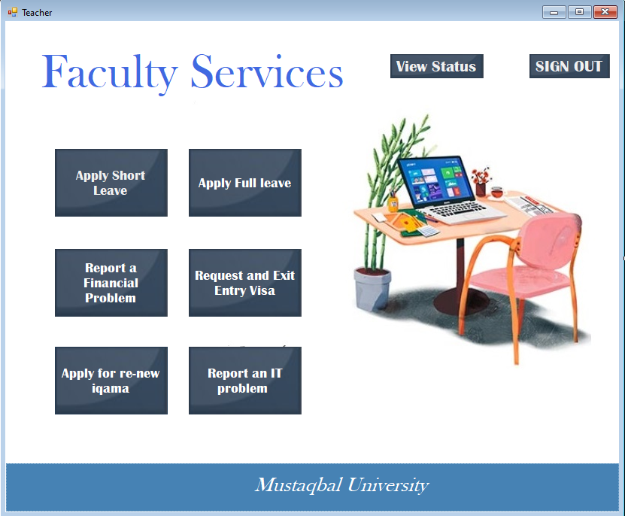

*Figure 3.34 Form of Teacher Home.*

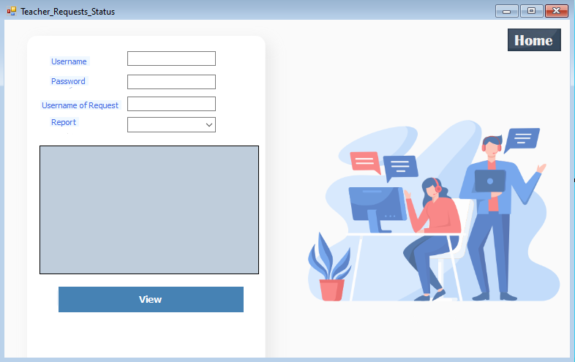

*Figure 3.35 Form of Teacher requests status.*

# 4

# **CHAPTER** 4

Development & Implementation

**1.3.3 Implementation**

This project will be implemented using Visual Studio as a environment language for C#,

* + - 1. **.NET**

.NET Framework was developed by Microsoft and runs primarily on Windows operating systems. There is an open source project as well – it’s called Mono. Mono delivers cross-platform .NET Framework compatible set of tools (like runtime, C# compiler, etc.).The framework provides language interoperability across several programming languages – each language can use code written in other languages.

.NET Framework contains a great set of libraries – it’s called Framework Class Library. It provides user interface controls, data access layers, network communications, cryptography etc.

**1.3.3.2 .NET Work Mechanism**

.NET Framework creates a software environment which is an hardware independent abstraction. Here is how it works: .NET applications are compiled to platform independent code called Common Intermediate Language (CIL). Before an application is executed it’s recompiled on the fly (by .NET Framework) to a platform specific code. This way .NET executable can work on various platforms without any change to itself. But there is one catch. The .NET Framework have to be installed on target platform. Additionally, .NET Framework is versioned and every .NET application is complied to work with specific framework version. It means that on target platform have to be installed the same framework version as required by the application.

**1.3.3.3 C#**

C# is a strongly typed object-oriented programming language. C# is open source, simple, modern, flexible, and versatile. In this article, let’s learn what C# is, what C# can do, and how C# is different than C++ and other programming languages. A programming language on computer science is a language that is used to write software programs.

C# is a programming language developed and launched by Microsoft in 2001. C# is a simple, modern, and object-oriented language that provides modern day developers flexibility and features to build software that will not only work today but will be applicable for years in the future.

**1.3.3.4 SQL – server**

SQL is standard of( Structure Query Languages ) SQL Server is a relational database management system, or (RDBMS), developed and marketed by Microsoft.

* + - 1. **visual Studio**

created by Microsoft, Visual Studio is an integrated development environment that is used to develop computer programs for Windows.

Visual studio can also be used for developing web sites, web applications, and web services. IT uses Microsoft software development platforms such as Windows API, Windows Forms, Windows Store, Windows Presentation Foundation, and Microsoft Silverlight,

Including a code editor that support IntelliSense, Visual Studio is written in C++ and C# and offers a an integrated debugger that works both as a source-level debugger and a machine level debugger.

**4.2 Development & Coding**

To develop this software, coding is performed using C#. The front end is connected with the backend using the SQL connections. Data is stored in the database and different users according to their privileges can view, approve or reject the requests.

In this section, I will explain important sections of code.

4.2.1: Database Connectivity

To connect with database sqlconnection is used and connection is opened and closed as per requirements. Sqlcommands and query is used to store and fetch data from database.

|  |
| --- |
| SqlConnection con1 = new SqlConnection(@"Data Source=(LocalDB)\v11.0;AttachDbFilename=""C:\Users\3bdallh\OneDrive - Almustaqbal University\mythesis\sql_data.mdf"";Integrated Security=True;Connect Timeout=30");  SqlDataAdapter sda = new SqlDataAdapter("Select Count(*) From Login where Username='" + textBox1.Text + "'", con1);  con.Open();  SqlCommand cmd = new SqlCommand("Insert into Login (Username, Password, Role) values ('" + textBox1.Text + "','" + textBox2.Text + "','" + comboBox1.SelectedItem + "')", con);  cmd.ExecuteNonQuery();  con.Close(); |

4.2.2. Sign Up

|  |
| --- |
| {  SqlConnection con1 = new SqlConnection(@"Data Source=(LocalDB)\v11.0;AttachDbFilename=""C:\Users\3bdallh\OneDrive - Almustaqbal University\mythesis\sql_data.mdf"";Integrated Security=True;Connect Timeout=30");  SqlDataAdapter sda = new SqlDataAdapter("Select Count(*) From Login where Username='" + textBox1.Text + "'", con1);  DataTable dt2 = new DataTable();  sda.Fill(dt2);  if (int.Parse(dt2.Rows[0][0].ToString()) == 0)  {  if (textBox2.Text == textBox3.Text)  {  SqlConnection con = new SqlConnection(@"Data Source=(LocalDB)\v11.0;AttachDbFilename=""C:\Users\3bdallh\OneDrive - Almustaqbal University\mythesis\sql_data.mdf"";Integrated Security=True;Connect Timeout=30");  con.Open();  SqlCommand cmd = new SqlCommand("Insert into Login (Username, Password, Role) values ('" + textBox1.Text + "','" + textBox2.Text + "','" + comboBox1.SelectedItem + "')", con);  cmd.ExecuteNonQuery();  con.Close();  MessageBox.Show("You are Registered");  }  else  {  MessageBox.Show("Password is not Same");  }  }  else  {  MessageBox.Show("This Name is Already in Use");  }  } |

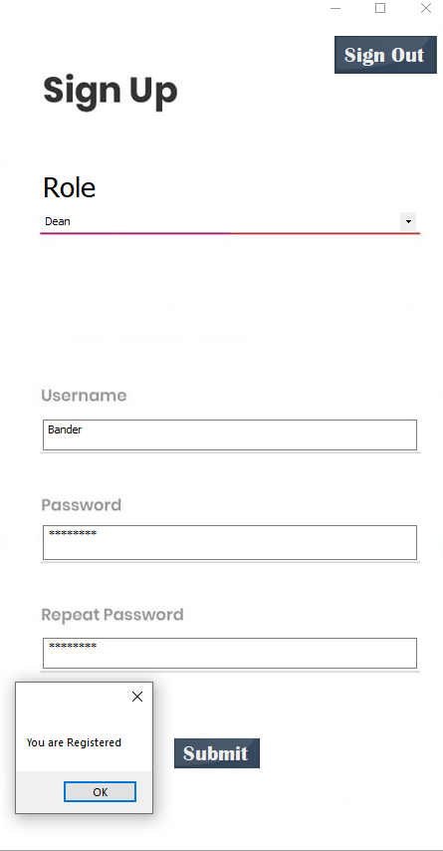

*Figure 4.1 create a new user*

4.2.3 Sign In

|  |
| --- |
| if (textBox1.Text == "")  {  MessageBox.Show("Please Enter Username");  }  else if (textBox2.Text == "")  {  MessageBox.Show("Please Enter Password");  }  else  {  SqlConnection con = new SqlConnection(@"Data Source=(LocalDB)\v11.0;AttachDbFilename=""C:\Users\3bdallh\OneDrive - Almustaqbal University\mythesis\sql_data.mdf"";Integrated Security=True;Connect Timeout=30");  SqlDataAdapter sda = new SqlDataAdapter("Select Count(*) From Login where Username='" + textBox1.Text + "'and Password='" + textBox2.Text + "'and Role='" + comboBox1.SelectedItem + "'", con);  DataTable dt = new DataTable();  sda.Fill(dt);  if (dt.Rows[0][0].ToString() == "1")  {  if (comboBox1.SelectedItem.ToString() == "HOD")  {  this.Hide();  Hod h1 = new Hod();  h1.Show();  }  else if (comboBox1.SelectedItem.ToString() == "Dean")  {  this.Hide();  Dean h6 = new Dean();  h6.Show();  }  else if (comboBox1.SelectedItem.ToString() == "Teacher")  {  this.Hide();  Teacher h2 = new Teacher();  h2.Show();  }  else if (comboBox1.SelectedItem.ToString() == "Student affer")  {  this.Hide();  student_aff_home h3 = new student_aff_home();  h3.Show();  }  else if (comboBox1.SelectedItem.ToString() == "Director")  {  this.Hide();  Director h4 = new Director();  h4.Show();  }  else if (comboBox1.SelectedItem.ToString() == "Admin")  {  this.Hide();  signup h6 = new signup();  h6.Show();  }  else if (comboBox1.SelectedItem.ToString() == "Credit Trasfer")  {  this.Hide();  Cred_Home h5 = new Cred_Home();  h5.Show();  }  }  else  {  MessageBox.Show("Username or Password is wrong");  }  } |

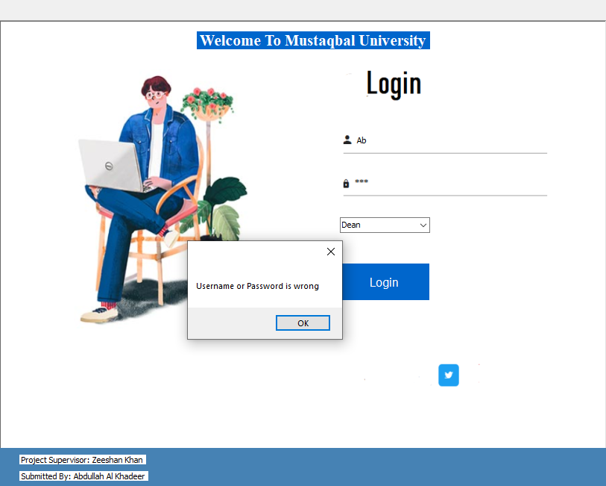

*Figure 4.2 wrong username or password*

4.2.4 Short Leave Submission

|  |
| --- |
| SqlConnection con = new SqlConnection(@"Data Source=(LocalDB)\v11.0;AttachDbFilename=""C:\Users\3bdallh\OneDrive - Almustaqbal University\mythesis\sql_data.mdf"";Integrated Security=True;Connect Timeout=30");  con.Open();  SqlCommand cmd2 = new SqlCommand("Insert into S_leave (Username, Date, Exit_Time, Entry_Time, Reason, Mobile_No, Status) values ('" + textBox1.Text + "','" + DateTime.Now + "','" + comboBox1.SelectedItem + "','" + comboBox2.SelectedItem + "','" + textBox4.Text + "','" + textBox3.Text + "','" + "0" + "')", con);  cmd2.ExecuteNonQuery();  MessageBox.Show("Your Request is Submitted Sucessfully ");  this.Hide();  Teacher t1 = new Teacher();  t1.Show();  con.Close();  }  private void label7_Click(object sender, EventArgs e)  {  }  private void button2_Click(object sender, EventArgs e)  {  this.Hide();  Teacher q1 = new Teacher();  q1.Show();  }  } |

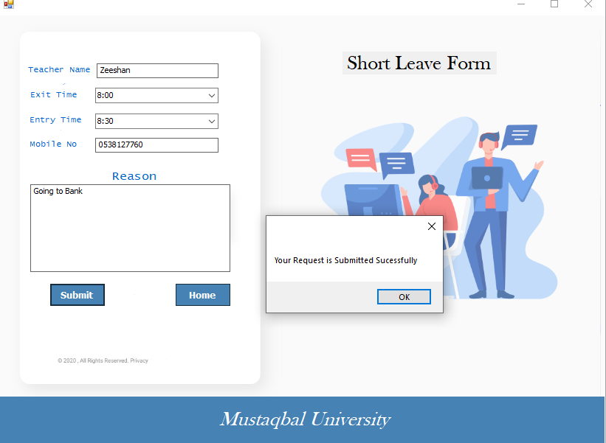

*Figure 4.3 short leave submission*

4.2.5 Approve from Dean

|  |
| --- |
| if (comboBox1.SelectedIndex == 0)  {  SqlConnection con = new SqlConnection(@"Data Source=(LocalDB)\v11.0;AttachDbFilename=""C:\Users\3bdallh\OneDrive - Almustaqbal University\mythesis\sql_data.mdf"";Integrated Security=True;Connect Timeout=30");  con.Open();  SqlCommand sqlda3 = new SqlCommand("update S_leave set Status=2 where ID='" + textBox1.Text + "'", con);  sqlda3.ExecuteNonQuery();  MessageBox.Show("Request is Approved");  string q1 = "select * from S_leave where ID = '" + textBox1.Text + "'";  SqlCommand sql4 = new SqlCommand(q1, con);  SqlDataReader dr1 = sql4.ExecuteReader();  try  {  MailMessage mail = new MailMessage();  SmtpClient SmtpServer = new SmtpClient("smtp.gmail.com");  mail.From = new MailAddress("Deanalmostaqbal@gmail.com");//dean email  mail.To.Add("ad.almostaqbal@gmail.com");//HR email  mail.Subject = "Approval of Short Leave";  while (dr1.Read())  {  string c = "Teacher Name is ";  c += dr1.GetString(0);  c += " Date of Application ";  c += dr1.GetString(1);  c += " Exit Time ";  c += dr1.GetString(2);  c += " Re-entry Time ";  c += dr1.GetString(3);  c += " Reason is ";  c += dr1.GetString(4);  c += " Mobile Number ";  c += dr1.GetString(5);  mail.Body = c;  }  SmtpServer.Port = 587;  SmtpServer.Credentials = new System.Net.NetworkCredential("Deanalmostaqbal@gmail.com", "Aa1234512345");//for dean correct username and password  SmtpServer.EnableSsl = true;  SmtpServer.Send(mail);  MessageBox.Show("mail Send");  }  catch (Exception ex)  {  MessageBox.Show(ex.ToString());  }  }  if (comboBox1.SelectedIndex == 2)  {  SqlConnection con = new SqlConnection(@"Data Source=(LocalDB)\v11.0;AttachDbFilename=""C:\Users\3bdallh\OneDrive - Almustaqbal University\mythesis\sql_data.mdf"";Integrated Security=True;Connect Timeout=30");  con.Open();  SqlCommand sqlda3 = new SqlCommand("update full_leave set Status=2 where ID='" + textBox1.Text + "'", con);  sqlda3.ExecuteNonQuery();  MessageBox.Show("Request is Approved");  string q1 = "select * from full_leave where ID = '" + textBox1.Text + "'";  SqlCommand sql4 = new SqlCommand(q1, con);  SqlDataReader dr1 = sql4.ExecuteReader();  try  {  MailMessage mail = new MailMessage();  SmtpClient SmtpServer = new SmtpClient("smtp.gmail.com");  mail.From = new MailAddress("Deanalmostaqbal@gmail.com");//dean email  mail.To.Add("ad.almostaqbal@gmail.com");//HR email  mail.Subject = "Approval of Short Leave";  while (dr1.Read())  {  string c = "Teacher Name is ";  c += dr1.GetString(0);  c += " Date of Application ";  c += dr1.GetString(1);  c += " Exit Time ";  c += dr1.GetString(2);  c += " Re-entry Time ";  c += dr1.GetString(3);  c += " Reason is ";  c += dr1.GetString(4);  c += " Mobile Number ";  c += dr1.GetString(5);  mail.Body = c;  }  SmtpServer.Port = 587;  SmtpServer.Credentials = new System.Net.NetworkCredential("Deanalmostaqbal@gmail.com", "Aa1234512345");//for dean correct username and password  SmtpServer.EnableSsl = true;  SmtpServer.Send(mail);  MessageBox.Show("mail Send");  }  catch (Exception ex)  {  MessageBox.Show(ex.ToString());  }  }  if (comboBox1.SelectedIndex == 4)  {  SqlConnection con = new SqlConnection(@"Data Source=(LocalDB)\v11.0;AttachDbFilename=""C:\Users\3bdallh\OneDrive - Almustaqbal University\mythesis\sql_data.mdf"";Integrated Security=True;Connect Timeout=30");  con.Open();  SqlCommand sqlda3 = new SqlCommand("update Equalization set status=4 where ID='" + textBox1.Text + "'", con);  sqlda3.ExecuteNonQuery();  MessageBox.Show("Request is Approved");  //send email to student  } |

4.2.4 Full Leave Submission

|  |
| --- |
| SqlConnection con = new SqlConnection(@"Data Source=(LocalDB)\v11.0;AttachDbFilename=""C:\Users\3bdallh\OneDrive - Almustaqbal University\mythesis\sql_data.mdf"";Integrated Security=True;Connect Timeout=30");  con.Open();  DateTime iDate;  iDate = dateTimePicker1.Value;  SqlCommand cmd2 = new SqlCommand("Insert into full_leave (Username, Start_Date, No_Days, Mobile_No, Reason, Status) values ('" + textBox1.Text + "','" + iDate + "','" + comboBox1.SelectedItem + "','" + textBox3.Text + "','" + textBox4.Text + "','" + "0" + "')", con);  cmd2.ExecuteNonQuery();  MessageBox.Show("Your Request is Submitted Sucessfully ");  this.Hide();  Teacher t1 = new Teacher();  t1.Show();  con.Close(); |

4.2.5 Notify by email

|  |
| --- |
| try  {  MailMessage mail = new MailMessage();  SmtpClient SmtpServer = new SmtpClient("smtp.gmail.com");  mail.From = new MailAddress("studentafaairs@gmail.com");//STUDENT AFFAIRS email  mail.To.Add(textBox1.Text);//STUDENT email  mail.Subject = "ALMOSTAQBAL University";  mail.Body = "Dear Student /n We're happy to inform you that your equlization is accepted you can get details from Student Affairs. ";  SmtpServer.Port = 587;  SmtpServer.Credentials = new System.Net.NetworkCredential("studentafaairs@gmail.com", "Aa1234512345");//for STUDENT AFFAIRS correct username and password  SmtpServer.EnableSsl = true;  SmtpServer.Send(mail);  MessageBox.Show("Mail Send");  }  catch (Exception ex)  {  MessageBox.Show(ex.ToString());  } |

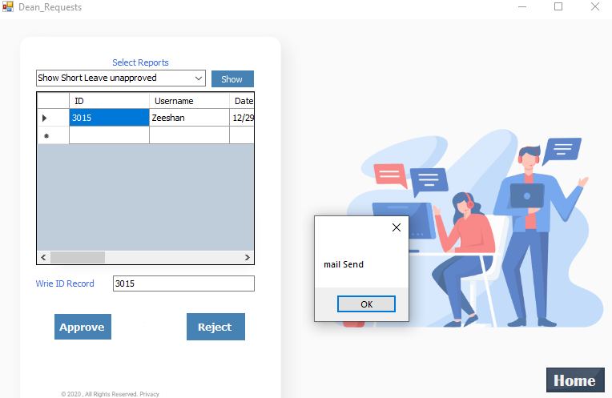

*Figure 4.4 send e-mail notification*

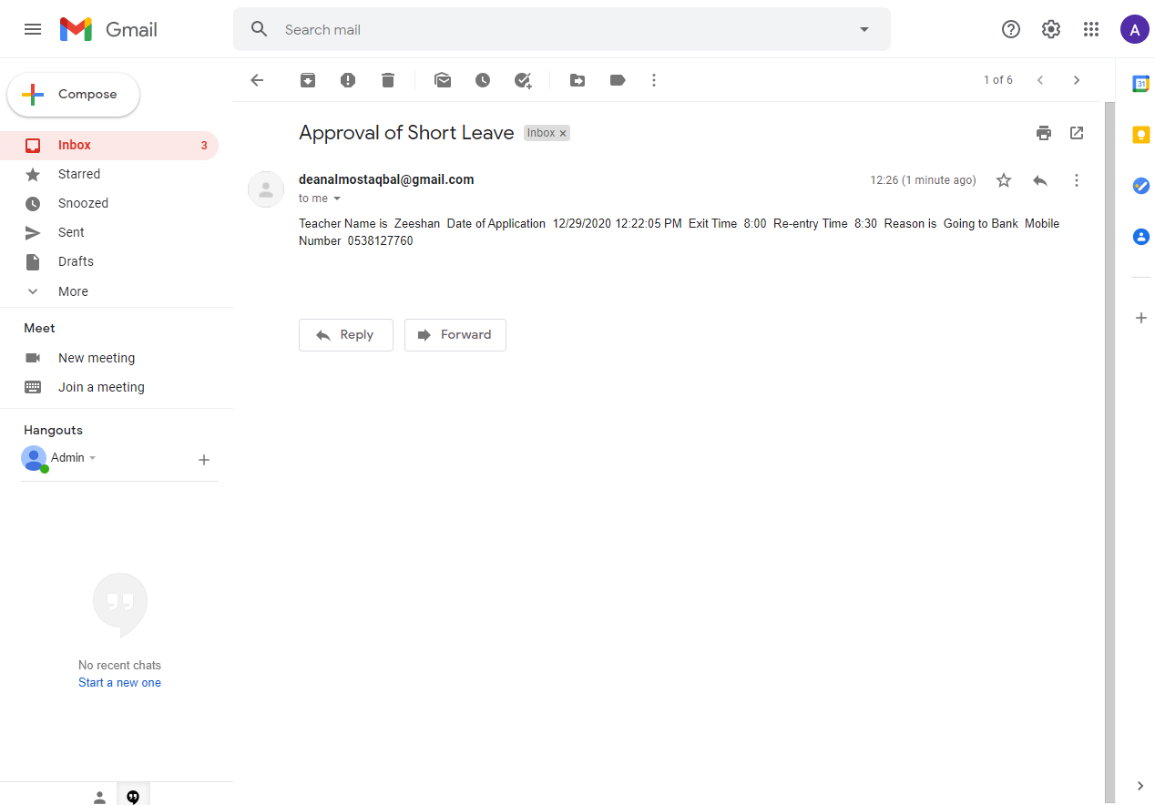

*Figure 4.5 e-mail inbox*

4.2.6 Fill Equalization Courses

|  |
| --- |
| SqlConnection con = new SqlConnection(@"Data Source=(LocalDB)\v11.0;AttachDbFilename=""C:\Users\3bdallh\OneDrive - Almustaqbal University\mythesis\sql_data.mdf"";Integrated Security=True;Connect Timeout=30");  con.Open();  string query = "insert into Equalization(academic_nu, name, status, previous_university, previous_college, specialization, previous_specialization, previous_academic_nu, total_courses, total_hours, c1, c2, c3, c4, c5, c6, c7, c8, c9, c10, c11, c12, c13, c14, c15, c16, c17, c18, c19, c20) Values ('" + textBox1.Text + "','" + textBox5.Text + "','" + "2" + "','" + textBox2.Text + "', '" + textBox6.Text + "','" + comboBox1.SelectedItem + "','" + textBox7.Text + "','" + textBox4.Text + "','" + comboBox1.SelectedItem + "','"+ textBox9.Text + "','" + comboBox2.SelectedItem + "','" + comboBox3.SelectedItem + "','"+ comboBox4.SelectedItem + "','"+ comboBox5.SelectedItem + "','"+ comboBox6.SelectedItem + "','"+ comboBox7.SelectedItem + "','"+ comboBox8.SelectedItem + "','"+ comboBox9.SelectedItem + "','"+ comboBox10.SelectedItem + "','"+ comboBox11.SelectedItem + "','"+ comboBox12.SelectedItem + "','"+ comboBox13.SelectedItem + "','"+ comboBox14.SelectedItem + "','"+ comboBox15.SelectedItem + "','"+ comboBox16.SelectedItem + "','"+ comboBox17.SelectedItem + "','"+ comboBox18.SelectedItem + "','"+ comboBox19.SelectedItem + "','"+ comboBox20.SelectedItem + "','"+ comboBox21.SelectedItem + "')";  SqlCommand cmd = new SqlCommand(query, con);  cmd.ExecuteNonQuery();  MessageBox.Show(" Equalization Enterd Successfully ");  SqlCommand sqlda3 = new SqlCommand("update student_affairs set status= 2 where academic_nu='" + textBox1.Text + "'", con);  sqlda3.ExecuteNonQuery(); |

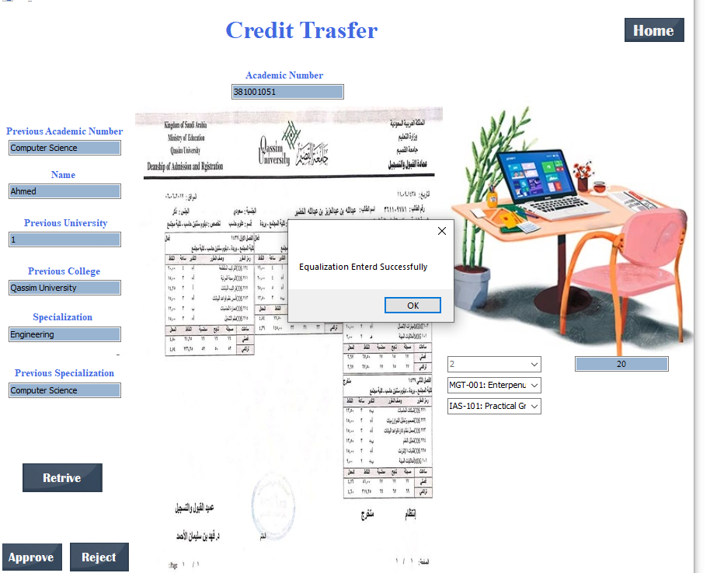

*Figure 4.6 Fill equalization*

4.2.7: Upload and store picture in Database

|  |
| --- |
| byte[] imgbt = null;  FileStream fstream = new FileStream(this.textBox3.Text, FileMode.Open, FileAccess.Read);  BinaryReader br = new BinaryReader(fstream);  imgbt = br.ReadBytes((int)fstream.Length);  SqlConnection con = new SqlConnection(@"Data Source=(LocalDB)\v11.0;AttachDbFilename=""C:\Users\3bdallh\OneDrive - Almustaqbal University\mythesis\sql_data.mdf"";Integrated Security=True;Connect Timeout=30");  string query = "insert into student_affairs(academic_nu, name, status, previous_university, previous_college, specialization, previous_specialization, previous_academic_nu, transcript) Values ('" + textBox1.Text + "','" + textBox5.Text + "','" + "0" + "','" + textBox2.Text + "', '" + textBox6.Text + "','" + comboBox1.SelectedItem + "','" + textBox7.Text + "','" + textBox4.Text + "',@IMG)";  SqlCommand cmd = new SqlCommand(query, con);  SqlDataReader dr;  try  {  con.Open();  cmd.Parameters.Add(new SqlParameter("@IMG", imgbt));  dr = cmd.ExecuteReader();  MessageBox.Show("Data sucessfully Saved");  while (dr.Read())  {  }  }  catch (Exception ex)  {  MessageBox.Show(ex.Message);  } |

# 5

# **CHAPTER** 5

Testing & Validation

Software Testing is an investigation conducted to provide stakeholders with information about the quality of the software product or service under test. Software testing can also provide an objective, independent view of the software to allow the business to appreciate and understand the risks of software implementation. Test techniques include the process of executing a program or application with the intent of finding software bugs (errors or other defects), and verifying that the software product is fit for use.

Software testing involves the execution of a software component or system component to evaluate one or more properties of interest. In general, these properties indicate the extent to which the component or system under test meets the requirements that guided its design and development- responds correctly to all kinds of inputs- performs its functions within an acceptable time- is sufficiently usable-

can be installed and run in its intended environments, and achieves the general result its stakeholders desire.

Software testing can be done by dedicated software testers. Until the 1980s, the term "software tester" was used generally, but later it was also seen as a separate profession. Regarding the periods and the different goals in software testing, different roles have been established, such as test manager, test lead, test analyst, test designer, tester, automation developer, and test administrator. Software testing can also be performed by non-dedicated software testers.

**5. 1 Black-box Testing**

Black-box testing is a method of software testing that examines the functionality of an application without peering into its internal structures or workings. This method of test can be applied virtually to every level of software testing: unit, integration, system and acceptance. It is sometimes referred to as specification-based testing.

**5.1.1 Test procedures**

Specific knowledge of the application's code/internal structure and programming knowledge in general is not required. The tester is aware of what the software is supposed to do but is not aware of how it does it. For instance, the tester is aware that a particular input returns a certain, invariable output but is not aware of how the software produces the output in the first place.

**5.2 White-box testing**

White-box testing (also known as clear box testing, glass box testing, transparent box testing, and structural testing) is a method of testing software that tests internal structures or workings of an application, as opposed to its functionality (i.e. black-box testing). In white-box testing an internal perspective of the system, as well as programming skills, are used to design test cases. The tester chooses inputs to exercise paths through the code and determine the expected outputs. This is analogous to testing nodes in a circuit, e.g. in-circuit testing (ICT). White-box testing can be applied at the unit, integration and system levels of the software testing process. Although traditional testers tended to think of white-box testing as being done at the unit level, it is used for integration and system testing more frequently today. It can test paths within a unit, paths between units during integration, and between subsystems during a system–level test. Though this method of test design can uncover many errors or problems, it has the potential to miss unimplemented parts of the specification or missing requirements.

**5.3 Test cases**

Test cases are built around specifications and requirements, i.e., what the application is supposed to do. Test cases are generally derived from external descriptions of the software, including specifications, requirements and design parameters. Although the tests used are primarily functional in nature, non-functional tests may also be used. The test designer selects both valid and invalid inputs and determines the correct output, often with the help of a test oracle or a previous result that is known to be good, without any knowledge of the test object's internal structure.

**Test Case 1: Login User**

Input: wrong password

Action: Login Request

Expected: “Username or Password wrong”

Actual output: “Username or Password wrong”

Result: Test Successful

**Test Case 2: Sign up User**

Input: Different passwords

Action: Sign up Request

Expected: “Passwords not same ”

Actual output: “Passwords not same”

Result: Test Successful

**Test Case 3:**

Input: Sign up a new user

Action: Sign up Request

Expected: “You are Registered”

Actual output: “You are Registered”

Result: Test Successful

**Test Case 4:**

Input: Fill equalization

Action: Fill equalization and fill courses

Expected: “Equalization Entered Successfully”

Actual output: “Equalization Entered Successfully”

Result: Test Successful

**Test Case 5:**

Input: Inform Student

Action: Inform Student

Expected: “An email will be sent to student”

Actual output: “Mail sent”

Result: Test Successful

**Test Case 6:**

Input: Submit short leave

Action: Submit short leave to management

Expected: “Your Request is Submitted Successfully”

Actual output: “Your Request is Submitted Successfully”

Result: Test Successful

**Test Case 7:**

Input: Submit full leave

Action: Submit short leave to management

Expected: “Your Request is Submitted Successfully”

Actual output: “Your Request is Submitted Successfully”

Result: Test Successful

**Test Case 8:**

Input: Dean approvals

Action: Approve equalization

Expected: “Request approved ”

Actual output: “Request approved ”

Result: Test Successful

**Test Case 9:**

Input: HoD approvals

Action: Approve equalization

Expected: “Request approved ”

Actual output: “Request approved ”

Result: Test Successful

**Test Case 10:**

Input: Dean rejects

Action: reject equalization

Expected: “Request rejected ”

Actual output: “Request rejected ”

Result: Test Successful

# 6

# **CHAPTER** 6

Conclusion & Future Work

This chapter concludes the project and the future work is also discussed in this project.

**6.1 Conclusion**

Credit transfer and faculty services management system is an electronics system that is developed to computerized few process of the Mustaqabal University. Faculty members in every university always need to communicate with different other departments of the university, including Administration, IT, HR and Finance sections. Most of the time the communication is paper based and a lot of time and efforts are required to complete the process and many times urgent items are delayed because of slow processes. To overcome this issue in this project, I developed an electronic system that enables the faculty and staff to communicate with various other department of the University by just few mouse clicks. On one side it saves the time b having a speedy process and on the other side it also reduces the cost that involved the cost of paper as well as cost of delivering papers from one place to another. Since we focused on Mustqbal University so all the processes are computerized by keeping the manual processes of Mustaqbal University in Mind. Following faculty services are computerized in this project:

* Short Leave Request
  + Fill short leave request
  + Approve short leave request from HoD
  + Approve short leave request from Dean
  + Inform HR department regarding short leave
* Full Leave Request
  + Fill Full leave request
  + Approve Full leave request from HoD
  + Approve Full leave request from Dean
  + Inform HR department regarding Full leave
* Report an IT Problem
* Report a Financial Problem
* Request for ID (Iqama) Renewal
* Request for Exit Re-Entry from Kingdom

Credit Transfer is currently performed by using paper based forms at Mustqbal University. I computerized the credit transfer process.

* Credit Transfer
  + Filling electronic forms for credit transfer
  + Attaching student’s transcripts
  + Approving credit transfer cases
  + Completing and entering equalized courses
  + Approving equalized courses from HoD and Dean
  + Communicating the Student Affair regarding completed cases
  + Communicating the student regarding completed cases

**6.2 Future Work**

In future following additions can be performed in this project:

* Remaining modules will be implemented
* Other processes of the university will be considered for implementation
* Administration side will be included in the system

**Appendix**

**Login**

|  |
| --- |
| using System;  using System.Collections.Generic;  using System.ComponentModel;  using System.Data;  using System.Drawing;  using System.Linq;  using System.Text;  using System.Threading.Tasks;  using System.Windows.Forms;  using System.Data.SqlClient;  namespace textboxes  {  public partial class Home : Form  {  public Home()  {  InitializeComponent();  }  private void button1_Click(object sender, EventArgs e)  {  if (textBox1.Text == "")  {  MessageBox.Show("Please Enter Username");  }  else if (textBox2.Text == "")  {  MessageBox.Show("Please Enter Password");  }  else  {  SqlConnection con = new SqlConnection(@"Data Source=(LocalDB)\v11.0;AttachDbFilename=""C:\Users\3bdallh\OneDrive - Almustaqbal University\mythesis\sql_data.mdf"";Integrated Security=True;Connect Timeout=30");  SqlDataAdapter sda = new SqlDataAdapter("Select Count(*) From Login where Username='" + textBox1.Text + "'and Password='" + textBox2.Text + "'and Role='" + comboBox1.SelectedItem + "'", con);  DataTable dt = new DataTable();  sda.Fill(dt);  if (dt.Rows[0][0].ToString() == "1")  {  if (comboBox1.SelectedItem.ToString() == "HOD")  {  this.Hide();  Hod h1 = new Hod();  h1.Show();  }  else if (comboBox1.SelectedItem.ToString() == "Dean")  {  this.Hide();  Dean h6 = new Dean();  h6.Show();  }  else if (comboBox1.SelectedItem.ToString() == "Teacher")  {  this.Hide();  Teacher h2 = new Teacher();  h2.Show();  }  else if (comboBox1.SelectedItem.ToString() == "Student affer")  {  this.Hide();  student_aff_home h3 = new student_aff_home();  h3.Show();  }  else if (comboBox1.SelectedItem.ToString() == "Director")  {  this.Hide();  Director h4 = new Director();  h4.Show();  }  else if (comboBox1.SelectedItem.ToString() == "Admin")  {  this.Hide();  signup h6 = new signup();  h6.Show();  }  else if (comboBox1.SelectedItem.ToString() == "Credit Trasfer")  {  this.Hide();  Cred_Home h5 = new Cred_Home();  h5.Show();  }  }  else  {  MessageBox.Show("Username or Password is wrong");  }  }  }  private void button2_Click(object sender, EventArgs e)  {  this.Hide();  signup ss = new signup();  ss.Show();  } |

**Sign up**

|  |
| --- |
| using System;  using System.Collections.Generic;  using System.ComponentModel;  using System.Data;  using System.Drawing;  using System.Linq;  using System.Text;  using System.Threading.Tasks;  using System.Windows.Forms;  using System.Data.SqlClient;  namespace textboxes  {  public partial class signup : Form  {  public signup()  {  InitializeComponent();  }  private void label3_Click(object sender, EventArgs e)  {  }  private void button1_Click_1(object sender, EventArgs e)  {  SqlConnection con1 = new SqlConnection(@"Data Source=(LocalDB)\v11.0;AttachDbFilename=""C:\Users\3bdallh\OneDrive - Almustaqbal University\mythesis\sql_data.mdf"";Integrated Security=True;Connect Timeout=30");  SqlDataAdapter sda = new SqlDataAdapter("Select Count(*) From Login where Username='" + textBox1.Text + "'", con1);  DataTable dt2 = new DataTable();  sda.Fill(dt2);  if (int.Parse(dt2.Rows[0][0].ToString()) == 0)  {  if (textBox2.Text == textBox3.Text)  {  SqlConnection con = new SqlConnection(@"Data Source=(LocalDB)\v11.0;AttachDbFilename=""C:\Users\3bdallh\OneDrive - Almustaqbal University\mythesis\sql_data.mdf"";Integrated Security=True;Connect Timeout=30");  con.Open();  SqlCommand cmd = new SqlCommand("Insert into Login (Username, Password, Role) values ('" + textBox1.Text + "','" + textBox2.Text + "','" + comboBox1.SelectedItem + "')", con);  cmd.ExecuteNonQuery();  con.Close();  MessageBox.Show("You are Registered");  }  else  {  MessageBox.Show("Password is not Same");  }  }  else  {  MessageBox.Show("This Name is Already in Use");  }  }  private void button2_Click_1(object sender, EventArgs e)  {  this.Hide();  Home q1 = new Home();  q1.Show();  } |

**Credit Transfer Home**

|  |
| --- |
| using System;  using System.Collections.Generic;  using System.ComponentModel;  using System.Data;  using System.Drawing;  using System.Linq;  using System.Text;  using System.Threading.Tasks;  using System.Windows.Forms;  using System.Data.SqlClient;  namespace textboxes  {  public partial class Cred_Home : Form  {  public Cred_Home()  {  InitializeComponent();  }  private void button1_Click(object sender, EventArgs e)  {  SqlConnection con = new SqlConnection(@"Data Source=(LocalDB)\v11.0;AttachDbFilename=""C:\Users\3bdallh\OneDrive - Almustaqbal University\mythesis\sql_data.mdf"";Integrated Security=True;Connect Timeout=30");  con.Open();  SqlDataAdapter sqlda3 = new SqlDataAdapter("SELECT academic_nu, name, status, previous_university, previous_college, specialization, previous_specialization, previous_academic_nu, transcript from student_affairs where status = 1", con);  DataTable dtb1 = new DataTable();  sqlda3.Fill(dtb1);  DG1.DataSource = dtb1;  if (dtb1.Rows.Count == 0)  {  MessageBox.Show("No Record is Found");  }  }  private void button2_Click(object sender, EventArgs e)  {  this.Hide();  fill_courses q1 = new fill_courses();  q1.Show();  }  private void button3_Click(object sender, EventArgs e)  {  this.Hide();  Home q1 = new Home();  q1.Show();  }  } |

**Dean Home**

|  |
| --- |
| using System;  using System.Collections.Generic;  using System.ComponentModel;  using System.Data;  using System.Drawing;  using System.Linq;  using System.Text;  using System.Threading.Tasks;  using System.Windows.Forms;  namespace textboxes  {  public partial class Dean : Form  {  public Dean()  {  InitializeComponent();  }  private void button1_Click(object sender, EventArgs e)  {  }  private void button7_Click(object sender, EventArgs e)  {  this.Hide();  Home q1 = new Home();  q1.Show();  }  private void button1_Click_1(object sender, EventArgs e)  {  this.Hide();  Dean_Requests q1 = new Dean_Requests();  q1.Show();  }  private void button2_Click(object sender, EventArgs e)  {  this.Hide();  eq_approve q1 = new eq_approve();  q1.Show();  }  } |

**Dean Requests**

|  |
| --- |
| using System;  using System.Collections.Generic;  using System.ComponentModel;  using System.Data;  using System.Drawing;  using System.Linq;  using System.Text;  using System.Threading.Tasks;  using System.Windows.Forms;  using System.Data.SqlClient;  using System.Net.Mail;  namespace textboxes  {  public partial class Dean_Requests : Form  {  public Dean_Requests()  {  InitializeComponent();  }  private void button1_Click(object sender, EventArgs e)  {  SqlConnection con = new SqlConnection(@"Data Source=(LocalDB)\v11.0;AttachDbFilename=""C:\Users\3bdallh\OneDrive - Almustaqbal University\mythesis\sql_data.mdf"";Integrated Security=True;Connect Timeout=30");  con.Open();  if (comboBox1.SelectedIndex == 0)  {  SqlDataAdapter sqlda3 = new SqlDataAdapter("Select Username, Date, Exit_Time, Entry_Time, Reason, Mobile_No, Status ,ID from S_leave where Status=1", con);  DataTable dtb1 = new DataTable();  sqlda3.Fill(dtb1);  DG1.DataSource = dtb1;  if (dtb1.Rows.Count == 0)  {  MessageBox.Show("No Record is Found");  }  }  else if (comboBox1.SelectedIndex == 1)  {  SqlDataAdapter sqlda3 = new SqlDataAdapter("Select Username, Date, Exit_Time, Entry_Time, Reason, Mobile_No, Status ,ID from S_leave where Status=2", con);  DataTable dtb1 = new DataTable();  sqlda3.Fill(dtb1);  DG1.DataSource = dtb1;  if (dtb1.Rows.Count == 0)  {  MessageBox.Show("No Record is Found");  }  }  else if (comboBox1.SelectedIndex == 2)  {  SqlDataAdapter sqlda3 = new SqlDataAdapter("Select Username, Start_Date, No_Days, Mobile_No, Reason, Status, ID from full_leave where Status=1", con);  DataTable dtb1 = new DataTable();  sqlda3.Fill(dtb1);  DG1.DataSource = dtb1;  if (dtb1.Rows.Count == 0)  {  MessageBox.Show("No Record is Found");  }  }  else if (comboBox1.SelectedIndex == 3)  {  SqlDataAdapter sqlda3 = new SqlDataAdapter("Select Username, Start_Date, No_Days, Mobile_No, Reason, Status, ID from full_leave where Status=2", con);  DataTable dtb1 = new DataTable();  sqlda3.Fill(dtb1);  DG1.DataSource = dtb1;  if (dtb1.Rows.Count == 0)  {  MessageBox.Show("No Record is Found");  }  }  else if (comboBox1.SelectedIndex == 4)  {  SqlDataAdapter sqlda3 = new SqlDataAdapter("Select ID, academic_nu, name, status, previous_university, previous_college, specialization, previous_specialization, previous_academic_nu, total_courses, total_hours, c1, c2, c3, c4, c5, c6, c7, c8, c9, c10, c11, c12, c13, c14, c15, c16, c17, c18, c19, c20 from Equalization where status=3", con);  DataTable dtb1 = new DataTable();  sqlda3.Fill(dtb1);  DG1.DataSource = dtb1;  if (dtb1.Rows.Count == 0)  {  MessageBox.Show("No Record is Found");  }  }  con.Close();  }  private void button2_Click(object sender, EventArgs e)  {  if (comboBox1.SelectedIndex == 0)  {  SqlConnection con = new SqlConnection(@"Data Source=(LocalDB)\v11.0;AttachDbFilename=""C:\Users\3bdallh\OneDrive - Almustaqbal University\mythesis\sql_data.mdf"";Integrated Security=True;Connect Timeout=30");  con.Open();  SqlCommand sqlda3 = new SqlCommand("update S_leave set Status=2 where ID='" + textBox1.Text + "'", con);  sqlda3.ExecuteNonQuery();  MessageBox.Show("Request is Approved");  string q1 = "select * from S_leave where ID = '" + textBox1.Text + "'";  SqlCommand sql4 = new SqlCommand(q1, con);  SqlDataReader dr1 = sql4.ExecuteReader();  try  {  MailMessage mail = new MailMessage();  SmtpClient SmtpServer = new SmtpClient("smtp.gmail.com");  mail.From = new MailAddress("Deanalmostaqbal@gmail.com");//dean email  mail.To.Add("ad.almostaqbal@gmail.com");//HR email  mail.Subject = "Approval of Short Leave";  while (dr1.Read())  {  string c = "Teacher Name is ";  c += dr1.GetString(0);  c += " Date of Application ";  c += dr1.GetString(1);  c += " Exit Time ";  c += dr1.GetString(2);  c += " Re-entry Time ";  c += dr1.GetString(3);  c += " Reason is ";  c += dr1.GetString(4);  c += " Mobile Number ";  c += dr1.GetString(5);  mail.Body = c;  }  SmtpServer.Port = 587;  SmtpServer.Credentials = new System.Net.NetworkCredential("Deanalmostaqbal@gmail.com", "Aa1234512345");//for dean correct username and password  SmtpServer.EnableSsl = true;  SmtpServer.Send(mail);  MessageBox.Show("mail Send");  }  catch (Exception ex)  {  MessageBox.Show(ex.ToString());  }  }  if (comboBox1.SelectedIndex == 2)  {  SqlConnection con = new SqlConnection(@"Data Source=(LocalDB)\v11.0;AttachDbFilename=""C:\Users\3bdallh\OneDrive - Almustaqbal University\mythesis\sql_data.mdf"";Integrated Security=True;Connect Timeout=30");  con.Open();  SqlCommand sqlda3 = new SqlCommand("update full_leave set Status=2 where ID='" + textBox1.Text + "'", con);  sqlda3.ExecuteNonQuery();  MessageBox.Show("Request is Approved");  string q1 = "select * from full_leave where ID = '" + textBox1.Text + "'";  SqlCommand sql4 = new SqlCommand(q1, con);  SqlDataReader dr1 = sql4.ExecuteReader();  try  {  MailMessage mail = new MailMessage();  SmtpClient SmtpServer = new SmtpClient("smtp.gmail.com");  mail.From = new MailAddress("Deanalmostaqbal@gmail.com");//dean email  mail.To.Add("ad.almostaqbal@gmail.com");//HR email  mail.Subject = "Approval of Short Leave";  while (dr1.Read())  {  string c = "Teacher Name is ";  c += dr1.GetString(0);  c += " Date of Application ";  c += dr1.GetString(1);  c += " Exit Time ";  c += dr1.GetString(2);  c += " Re-entry Time ";  c += dr1.GetString(3);  c += " Reason is ";  c += dr1.GetString(4);  c += " Mobile Number ";  c += dr1.GetString(5);  mail.Body = c;  }  SmtpServer.Port = 587;  SmtpServer.Credentials = new System.Net.NetworkCredential("Deanalmostaqbal@gmail.com", "Aa1234512345");//for dean correct username and password  SmtpServer.EnableSsl = true;  SmtpServer.Send(mail);  MessageBox.Show("mail Send");  }  catch (Exception ex)  {  MessageBox.Show(ex.ToString());  }  }  if (comboBox1.SelectedIndex == 4)  {  SqlConnection con = new SqlConnection(@"Data Source=(LocalDB)\v11.0;AttachDbFilename=""C:\Users\3bdallh\OneDrive - Almustaqbal University\mythesis\sql_data.mdf"";Integrated Security=True;Connect Timeout=30");  con.Open();  SqlCommand sqlda3 = new SqlCommand("update Equalization set status=4 where ID='" + textBox1.Text + "'", con);  sqlda3.ExecuteNonQuery();  MessageBox.Show("Request is Approved");  //send email to student  }  }  private void button4_Click(object sender, EventArgs e)  {  if (comboBox1.SelectedIndex == 0)  {  SqlConnection con = new SqlConnection(@"Data Source=(LocalDB)\v11.0;AttachDbFilename=""C:\Users\3bdallh\OneDrive - Almustaqbal University\mythesis\sql_data.mdf"";Integrated Security=True;Connect Timeout=30");  con.Open();  SqlCommand sqlda3 = new SqlCommand("update S_leave set Status=-1 where ID='" + textBox1.Text + "'", con);  sqlda3.ExecuteNonQuery();  MessageBox.Show("Request is Successfully Rejected");  }  if (comboBox1.SelectedIndex == 2)  {  SqlConnection con = new SqlConnection(@"Data Source=(LocalDB)\v11.0;AttachDbFilename=""C:\Users\3bdallh\OneDrive - Almustaqbal University\mythesis\sql_data.mdf"";Integrated Security=True;Connect Timeout=30");  con.Open();  SqlCommand sqlda3 = new SqlCommand("update full_leave set Status=-1 where ID='" + textBox1.Text + "'", con);  sqlda3.ExecuteNonQuery();  MessageBox.Show("Request is Successfully Rejected");  }    }  private void button3_Click(object sender, EventArgs e)  {  this.Hide();  Dean q1 = new Dean();  q1.Show();  }  } |

**Equalization Request**

|  |
| --- |
| using System;  using System.Collections.Generic;  using System.ComponentModel;  using System.Data;  using System.Drawing;  using System.Linq;  using System.Text;  using System.Threading.Tasks;  using System.Windows.Forms;  using System.Data.SqlClient;  using System.IO;  namespace textboxes  {  public partial class eq_approve : Form  {  public eq_approve()  {  InitializeComponent();  }  private void eq_approve_Load(object sender, EventArgs e)  {  SqlConnection con = new SqlConnection(@"Data Source=(LocalDB)\v11.0;AttachDbFilename=""C:\Users\3bdallh\OneDrive - Almustaqbal University\mythesis\sql_data.mdf"";Integrated Security=True;Connect Timeout=30");  SqlDataAdapter sqlda3 = new SqlDataAdapter("Select academic_nu, name, status from student_affairs where status= 0 ", con);  DataTable dtb1 = new DataTable();  sqlda3.Fill(dtb1);  DG1.DataSource = dtb1;  }  private void button1_Click(object sender, EventArgs e)  {  SqlConnection con1 = new SqlConnection(@"Data Source=(LocalDB)\v11.0;AttachDbFilename=""C:\Users\3bdallh\OneDrive - Almustaqbal University\mythesis\sql_data.mdf"";Integrated Security=True;Connect Timeout=30");  string query1 = "select * from student_affairs where academic_nu='" + textBox1.Text + "'";  SqlCommand cmd1 = new SqlCommand(query1, con1);  SqlDataReader dr1;  try  {  con1.Open();  dr1 = cmd1.ExecuteReader();  while (dr1.Read())  {  textBox4.Text = dr1.GetString(6);  textBox5.Text = dr1.GetString(1);  textBox2.Text = dr1.GetString(2);  textBox6.Text = dr1.GetString(3);  textBox8.Text = dr1.GetString(4);  textBox7.Text = dr1.GetString(5);    byte[] imgg = (byte[])(dr1["transcript"]);//image is name of table column in database  if (imgg == null)  {  pictureBox1.Image = null;  }  else  {  MemoryStream mst = new MemoryStream(imgg);  pictureBox1.Image = System.Drawing.Image.FromStream(mst);  }  }  }  catch (Exception ex)  {  MessageBox.Show(ex.Message);  }  }  private void label4_Click(object sender, EventArgs e)  {  }  private void label2_Click(object sender, EventArgs e)  {  }  private void label6_Click(object sender, EventArgs e)  {  }  private void label5_Click(object sender, EventArgs e)  {  }  private void label7_Click(object sender, EventArgs e)  {  }  private void label8_Click(object sender, EventArgs e)  {  }  private void label10_Click(object sender, EventArgs e)  {  }  private void label9_Click(object sender, EventArgs e)  {  }  private void button3_Click(object sender, EventArgs e)  {  SqlConnection con1 = new SqlConnection(@"Data Source=(LocalDB)\v11.0;AttachDbFilename=""C:\Users\3bdallh\OneDrive - Almustaqbal University\mythesis\sql_data.mdf"";Integrated Security=True;Connect Timeout=30");  con1.Open();  SqlCommand sqlda5 = new SqlCommand("update student_affairs set status=1 where academic_nu='" + textBox1.Text + "'", con1);  sqlda5.ExecuteNonQuery();  MessageBox.Show("Equalization is Approved");  textBox1.Text = String.Empty;  textBox4.Text = String.Empty;  textBox5.Text = String.Empty;  textBox2.Text = String.Empty;  textBox6.Text = String.Empty;  textBox8.Text = String.Empty;  textBox7.Text = String.Empty;  pictureBox1.InitialImage = null;  con1.Close();  }  private void button4_Click(object sender, EventArgs e)  {  SqlConnection con1 = new SqlConnection(@"Data Source=(LocalDB)\v11.0;AttachDbFilename=""C:\Users\3bdallh\OneDrive - Almustaqbal University\mythesis\sql_data.mdf"";Integrated Security=True;Connect Timeout=30");  con1.Open();  SqlCommand sqlda5 = new SqlCommand("update student_affairs set status=-1 where academic_nu='" + textBox1.Text + "'", con1);  sqlda5.ExecuteNonQuery();  MessageBox.Show("Equalization is Rejected");  con1.Close();  }  private void dataGridView1_CellContentClick(object sender, DataGridViewCellEventArgs e)  {  }  private void button5_Click(object sender, EventArgs e)  {  this.Hide();  Dean q1 = new Dean();  q1.Show();  }  } |

**Credit Transfer**

|  |
| --- |
| using System;  using System.Collections.Generic;  using System.ComponentModel;  using System.Data;  using System.Drawing;  using System.Linq;  using System.Text;  using System.Threading.Tasks;  using System.Windows.Forms;  using System.Data.SqlClient;  using System.IO;  namespace textboxes  {  public partial class fill_courses : Form  {  public fill_courses()  {  InitializeComponent();  }  private void button1_Click(object sender, EventArgs e)  {  SqlConnection con1 = new SqlConnection(@"Data Source=(LocalDB)\v11.0;AttachDbFilename=""C:\Users\3bdallh\OneDrive - Almustaqbal University\mythesis\sql_data.mdf"";Integrated Security=True;Connect Timeout=30");  string query1 = "select * from student_affairs where academic_nu='" + textBox1.Text + "'";  SqlCommand cmd1 = new SqlCommand(query1, con1);  SqlDataReader dr1;  try  {  con1.Open();  dr1 = cmd1.ExecuteReader();  while (dr1.Read())  {  textBox4.Text = dr1.GetString(6);  textBox5.Text = dr1.GetString(1);  textBox2.Text = dr1.GetString(2);  textBox6.Text = dr1.GetString(3);  textBox8.Text = dr1.GetString(4);  textBox7.Text = dr1.GetString(5);  byte[] imgg = (byte[])(dr1["transcript"]);//image is name of table column in database  if (imgg == null)  {  pictureBox1.Image = null;  }  else  {  MemoryStream mst = new MemoryStream(imgg);  pictureBox1.Image = System.Drawing.Image.FromStream(mst);  }  }  }  catch (Exception ex)  {  MessageBox.Show(ex.Message);  }  }  private void comboBox12_SelectedIndexChanged(object sender, EventArgs e)  {  }  private void comboBox1_SelectedIndexChanged(object sender, EventArgs e)  {  if (comboBox1.SelectedIndex == 0)  {  comboBox2.Visible = true;  comboBox3.Visible = false;  comboBox4.Visible = false;  comboBox5.Visible = false;  comboBox6.Visible = false;  comboBox7.Visible = false;  comboBox8.Visible = false;  comboBox9.Visible = false;  comboBox10.Visible = false;  comboBox11.Visible = false;  comboBox12.Visible = false;  comboBox13.Visible = false;  comboBox14.Visible = false;  comboBox15.Visible = false;  comboBox16.Visible = false;  comboBox17.Visible = false;  comboBox18.Visible = false;  comboBox19.Visible = false;  comboBox20.Visible = false;  comboBox21.Visible = false;  }  if (comboBox1.SelectedIndex == 1)  {  comboBox2.Visible = true;  comboBox3.Visible = true;  comboBox4.Visible = false;  comboBox5.Visible = false;  comboBox6.Visible = false;  comboBox7.Visible = false;  comboBox8.Visible = false;  comboBox9.Visible = false;  comboBox10.Visible = false;  comboBox11.Visible = false;  comboBox12.Visible = false;  comboBox13.Visible = false;  comboBox14.Visible = false;  comboBox15.Visible = false;  comboBox16.Visible = false;  comboBox17.Visible = false;  comboBox18.Visible = false;  comboBox19.Visible = false;  comboBox20.Visible = false;  comboBox21.Visible = false;  }  if (comboBox1.SelectedIndex == 2)  {  comboBox2.Visible = true;  comboBox3.Visible = true;  comboBox4.Visible = true;  comboBox5.Visible = false;  comboBox6.Visible = false;  comboBox7.Visible = false;  comboBox8.Visible = false;  comboBox9.Visible = false;  comboBox10.Visible = false;  comboBox11.Visible = false;  comboBox12.Visible = false;  comboBox13.Visible = false;  comboBox14.Visible = false;  comboBox15.Visible = false;  comboBox16.Visible = false;  comboBox17.Visible = false;  comboBox18.Visible = false;  comboBox19.Visible = false;  comboBox20.Visible = false;  comboBox21.Visible = false;  }  if (comboBox1.SelectedIndex == 3)  {  comboBox2.Visible = true;  comboBox3.Visible = true;  comboBox4.Visible = true;  comboBox5.Visible = true;  comboBox6.Visible = false;  comboBox7.Visible = false;  comboBox8.Visible = false;  comboBox9.Visible = false;  comboBox10.Visible = false;  comboBox11.Visible = false;  comboBox12.Visible = false;  comboBox13.Visible = false;  comboBox14.Visible = false;  comboBox15.Visible = false;  comboBox16.Visible = false;  comboBox17.Visible = false;  comboBox18.Visible = false;  comboBox19.Visible = false;  comboBox20.Visible = false;  comboBox21.Visible = false;  }  if (comboBox1.SelectedIndex == 4)  {  comboBox2.Visible = true;  comboBox3.Visible = true;  comboBox4.Visible = true;  comboBox5.Visible = true;  comboBox6.Visible = true;  comboBox7.Visible = false;  comboBox8.Visible = false;  comboBox9.Visible = false;  comboBox10.Visible = false;  comboBox11.Visible = false;  comboBox12.Visible = false;  comboBox13.Visible = false;  comboBox14.Visible = false;  comboBox15.Visible = false;  comboBox16.Visible = false;  comboBox17.Visible = false;  comboBox18.Visible = false;  comboBox19.Visible = false;  comboBox20.Visible = false;  comboBox21.Visible = false;  }  if (comboBox1.SelectedIndex == 5)  {  comboBox2.Visible = true;  comboBox3.Visible = true;  comboBox4.Visible = true;  comboBox5.Visible = true;  comboBox6.Visible = true;  comboBox7.Visible = true;  comboBox8.Visible = false;  comboBox9.Visible = false;  comboBox10.Visible = false;  comboBox11.Visible = false;  comboBox12.Visible = false;  comboBox13.Visible = false;  comboBox14.Visible = false;  comboBox15.Visible = false;  comboBox16.Visible = false;  comboBox17.Visible = false;  comboBox18.Visible = false;  comboBox19.Visible = false;  comboBox20.Visible = false;  comboBox21.Visible = false;  }  if (comboBox1.SelectedIndex == 6)  {  comboBox2.Visible = true;  comboBox3.Visible = true;  comboBox4.Visible = true;  comboBox5.Visible = true;  comboBox6.Visible = true;  comboBox7.Visible = true;  comboBox8.Visible = true;  comboBox9.Visible = false;  comboBox10.Visible = false;  comboBox11.Visible = false;  comboBox12.Visible = false;  comboBox13.Visible = false;  comboBox14.Visible = false;  comboBox15.Visible = false;  comboBox16.Visible = false;  comboBox17.Visible = false;  comboBox18.Visible = false;  comboBox19.Visible = false;  comboBox20.Visible = false;  comboBox21.Visible = false;  }  if (comboBox1.SelectedIndex == 7)  {  comboBox2.Visible = true;  comboBox3.Visible = true;  comboBox4.Visible = true;  comboBox5.Visible = true;  comboBox6.Visible = true;  comboBox7.Visible = true;  comboBox8.Visible = true;  comboBox9.Visible = true;  comboBox10.Visible = false;  comboBox11.Visible = false;  comboBox12.Visible = false;  comboBox13.Visible = false;  comboBox14.Visible = false;  comboBox15.Visible = false;  comboBox16.Visible = false;  comboBox17.Visible = false;  comboBox18.Visible = false;  comboBox19.Visible = false;  comboBox20.Visible = false;  comboBox21.Visible = false;  }  if (comboBox1.SelectedIndex == 8)  {  comboBox2.Visible = true;  comboBox3.Visible = true;  comboBox4.Visible = true;  comboBox5.Visible = true;  comboBox6.Visible = true;  comboBox7.Visible = true;  comboBox8.Visible = true;  comboBox9.Visible = true;  comboBox10.Visible = true;  comboBox11.Visible = false;  comboBox12.Visible = false;  comboBox13.Visible = false;  comboBox14.Visible = false;  comboBox15.Visible = false;  comboBox16.Visible = false;  comboBox17.Visible = false;  comboBox18.Visible = false;  comboBox19.Visible = false;  comboBox20.Visible = false;  comboBox21.Visible = false;  }  if (comboBox1.SelectedIndex == 9)  {  comboBox2.Visible = true;  comboBox3.Visible = true;  comboBox4.Visible = true;  comboBox5.Visible = true;  comboBox6.Visible = true;  comboBox7.Visible = true;  comboBox8.Visible = true;  comboBox9.Visible = true;  comboBox10.Visible = true;  comboBox11.Visible = true;  comboBox12.Visible = false;  comboBox13.Visible = false;  comboBox14.Visible = false;  comboBox15.Visible = false;  comboBox16.Visible = false;  comboBox17.Visible = false;  comboBox18.Visible = false;  comboBox19.Visible = false;  comboBox20.Visible = false;  comboBox21.Visible = false;  }  if (comboBox1.SelectedIndex == 10)  {  comboBox2.Visible = true;  comboBox3.Visible = true;  comboBox4.Visible = true;  comboBox5.Visible = true;  comboBox6.Visible = true;  comboBox7.Visible = true;  comboBox8.Visible = true;  comboBox9.Visible = true;  comboBox10.Visible = true;  comboBox11.Visible = true;  comboBox12.Visible = true;  comboBox13.Visible = false;  comboBox14.Visible = false;  comboBox15.Visible = false;  comboBox16.Visible = false;  comboBox17.Visible = false;  comboBox18.Visible = false;  comboBox19.Visible = false;  comboBox20.Visible = false;  comboBox21.Visible = false;  }  if (comboBox1.SelectedIndex == 11)  {  comboBox2.Visible = true;  comboBox3.Visible = true;  comboBox4.Visible = true;  comboBox5.Visible = true;  comboBox6.Visible = true;  comboBox7.Visible = true;  comboBox8.Visible = true;  comboBox9.Visible = true;  comboBox10.Visible = true;  comboBox11.Visible = true;  comboBox12.Visible = true;  comboBox13.Visible = true;  comboBox14.Visible = false;  comboBox15.Visible = false;  comboBox16.Visible = false;  comboBox17.Visible = false;  comboBox18.Visible = false;  comboBox19.Visible = false;  comboBox20.Visible = false;  comboBox21.Visible = false;  }  if (comboBox1.SelectedIndex == 12)  {  comboBox2.Visible = true;  comboBox3.Visible = true;  comboBox4.Visible = true;  comboBox5.Visible = true;  comboBox6.Visible = true;  comboBox7.Visible = true;  comboBox8.Visible = true;  comboBox9.Visible = true;  comboBox10.Visible = true;  comboBox11.Visible = true;  comboBox12.Visible = true;  comboBox13.Visible = true;  comboBox14.Visible = true;  comboBox15.Visible = false;  comboBox16.Visible = false;  comboBox17.Visible = false;  comboBox18.Visible = false;  comboBox19.Visible = false;  comboBox20.Visible = false;  comboBox21.Visible = false;  }  if (comboBox1.SelectedIndex == 13)  {  comboBox2.Visible = true;  comboBox3.Visible = true;  comboBox4.Visible = true;  comboBox5.Visible = true;  comboBox6.Visible = true;  comboBox7.Visible = true;  comboBox8.Visible = true;  comboBox9.Visible = true;  comboBox10.Visible = true;  comboBox11.Visible = true;  comboBox12.Visible = true;  comboBox13.Visible = true;  comboBox14.Visible = true;  comboBox15.Visible = true;  comboBox16.Visible = false;  comboBox17.Visible = false;  comboBox18.Visible = false;  comboBox19.Visible = false;  comboBox20.Visible = false;  comboBox21.Visible = false;  }  if (comboBox1.SelectedIndex == 14)  {  comboBox2.Visible = true;  comboBox3.Visible = true;  comboBox4.Visible = true;  comboBox5.Visible = true;  comboBox6.Visible = true;  comboBox7.Visible = true;  comboBox8.Visible = true;  comboBox9.Visible = true;  comboBox10.Visible = true;  comboBox11.Visible = true;  comboBox12.Visible = true;  comboBox13.Visible = true;  comboBox14.Visible = true;  comboBox15.Visible = true;  comboBox16.Visible = true;  comboBox17.Visible = false;  comboBox18.Visible = false;  comboBox19.Visible = false;  comboBox20.Visible = false;  comboBox21.Visible = false;  }  if (comboBox1.SelectedIndex == 15)  {  comboBox2.Visible = true;  comboBox3.Visible = true;  comboBox4.Visible = true;  comboBox5.Visible = true;  comboBox6.Visible = true;  comboBox7.Visible = true;  comboBox8.Visible = true;  comboBox9.Visible = true;  comboBox10.Visible = true;  comboBox11.Visible = true;  comboBox12.Visible = true;  comboBox13.Visible = true;  comboBox14.Visible = true;  comboBox15.Visible = true;  comboBox16.Visible = true;  comboBox17.Visible = true;  comboBox18.Visible = false;  comboBox19.Visible = false;  comboBox20.Visible = false;  comboBox21.Visible = false;  }  if (comboBox1.SelectedIndex == 16)  {  comboBox2.Visible = true;  comboBox3.Visible = true;  comboBox4.Visible = true;  comboBox5.Visible = true;  comboBox6.Visible = true;  comboBox7.Visible = true;  comboBox8.Visible = true;  comboBox9.Visible = true;  comboBox10.Visible = true;  comboBox11.Visible = true;  comboBox12.Visible = true;  comboBox13.Visible = true;  comboBox14.Visible = true;  comboBox15.Visible = true;  comboBox16.Visible = true;  comboBox17.Visible = true;  comboBox18.Visible = true;  comboBox19.Visible = false;  comboBox20.Visible = false;  comboBox21.Visible = false;  }  if (comboBox1.SelectedIndex == 17)  {  comboBox2.Visible = true;  comboBox3.Visible = true;  comboBox4.Visible = true;  comboBox5.Visible = true;  comboBox6.Visible = true;  comboBox7.Visible = true;  comboBox8.Visible = true;  comboBox9.Visible = true;  comboBox10.Visible = true;  comboBox11.Visible = true;  comboBox12.Visible = true;  comboBox13.Visible = true;  comboBox14.Visible = true;  comboBox15.Visible = true;  comboBox16.Visible = true;  comboBox17.Visible = true;  comboBox18.Visible = true;  comboBox19.Visible = true;  comboBox20.Visible = false;  comboBox21.Visible = false;  }  if (comboBox1.SelectedIndex == 18)  {  comboBox2.Visible = true;  comboBox3.Visible = true;  comboBox4.Visible = true;  comboBox5.Visible = true;  comboBox6.Visible = true;  comboBox7.Visible = true;  comboBox8.Visible = true;  comboBox9.Visible = true;  comboBox10.Visible = true;  comboBox11.Visible = true;  comboBox12.Visible = true;  comboBox13.Visible = true;  comboBox14.Visible = true;  comboBox15.Visible = true;  comboBox16.Visible = true;  comboBox17.Visible = true;  comboBox18.Visible = true;  comboBox19.Visible = true;  comboBox20.Visible = true;  comboBox21.Visible = false;  }  if (comboBox1.SelectedIndex == 19)  {  comboBox2.Visible = true;  comboBox3.Visible = true;  comboBox4.Visible = true;  comboBox5.Visible = true;  comboBox6.Visible = true;  comboBox7.Visible = true;  comboBox8.Visible = true;  comboBox9.Visible = true;  comboBox10.Visible = true;  comboBox11.Visible = true;  comboBox12.Visible = true;  comboBox13.Visible = true;  comboBox14.Visible = true;  comboBox15.Visible = true;  comboBox16.Visible = true;  comboBox17.Visible = true;  comboBox18.Visible = true;  comboBox19.Visible = true;  comboBox20.Visible = true;  comboBox21.Visible = true;  }    }  private void fill_courses_Load(object sender, EventArgs e)  {  comboBox2.Visible = false;  comboBox3.Visible = false;  comboBox4.Visible = false;  comboBox5.Visible = false;  comboBox6.Visible = false;  comboBox7.Visible = false;  comboBox8.Visible = false;  comboBox9.Visible = false;  comboBox10.Visible = false;  comboBox11.Visible = false;  comboBox12.Visible = false;  comboBox13.Visible = false;  comboBox14.Visible = false;  comboBox15.Visible = false;  comboBox16.Visible = false;  comboBox17.Visible = false;  comboBox18.Visible = false;  comboBox19.Visible = false;  comboBox20.Visible = false;  comboBox21.Visible = false;  }  private void button3_Click(object sender, EventArgs e)  {  SqlConnection con = new SqlConnection(@"Data Source=(LocalDB)\v11.0;AttachDbFilename=""C:\Users\3bdallh\OneDrive - Almustaqbal University\mythesis\sql_data.mdf"";Integrated Security=True;Connect Timeout=30");  con.Open();  string query = "insert into Equalization(academic_nu, name, status, previous_university, previous_college, specialization, previous_specialization, previous_academic_nu, total_courses, total_hours, c1, c2, c3, c4, c5, c6, c7, c8, c9, c10, c11, c12, c13, c14, c15, c16, c17, c18, c19, c20) Values ('" + textBox1.Text + "','" + textBox5.Text + "','" + "2" + "','" + textBox2.Text + "', '" + textBox6.Text + "','" + comboBox1.SelectedItem + "','" + textBox7.Text + "','" + textBox4.Text + "','" + comboBox1.SelectedItem + "','"+ textBox9.Text + "','" + comboBox2.SelectedItem + "','" + comboBox3.SelectedItem + "','"+ comboBox4.SelectedItem + "','"+ comboBox5.SelectedItem + "','"+ comboBox6.SelectedItem + "','"+ comboBox7.SelectedItem + "','"+ comboBox8.SelectedItem + "','"+ comboBox9.SelectedItem + "','"+ comboBox10.SelectedItem + "','"+ comboBox11.SelectedItem + "','"+ comboBox12.SelectedItem + "','"+ comboBox13.SelectedItem + "','"+ comboBox14.SelectedItem + "','"+ comboBox15.SelectedItem + "','"+ comboBox16.SelectedItem + "','"+ comboBox17.SelectedItem + "','"+ comboBox18.SelectedItem + "','"+ comboBox19.SelectedItem + "','"+ comboBox20.SelectedItem + "','"+ comboBox21.SelectedItem + "')";  SqlCommand cmd = new SqlCommand(query, con);  cmd.ExecuteNonQuery();  MessageBox.Show(" Equalization Enterd Successfully ");  SqlCommand sqlda3 = new SqlCommand("update student_affairs set status= 2 where academic_nu='" + textBox1.Text + "'", con);  sqlda3.ExecuteNonQuery();    }  private void button2_Click(object sender, EventArgs e)  {  this.Hide();  Cred_Home q1 = new Cred_Home();  q1.Show();  }  private void textBox9_TextChanged(object sender, EventArgs e)  {  }  private void button4_Click(object sender, EventArgs e)  {  SqlConnection con = new SqlConnection(@"Data Source=(LocalDB)\v11.0;AttachDbFilename=""C:\Users\3bdallh\OneDrive - Almustaqbal University\mythesis\sql_data.mdf"";Integrated Security=True;Connect Timeout=30");  con.Open();  SqlCommand sqlda3 = new SqlCommand("update student_affairs set status= -1 where academic_nu='" + textBox1.Text + "'", con);  sqlda3.ExecuteNonQuery();  MessageBox.Show(" Equalization Request is Rejected ");  }  } |

**Full Leave**

|  |
| --- |
| using System;  using System.Collections.Generic;  using System.ComponentModel;  using System.Data;  using System.Drawing;  using System.Linq;  using System.Text;  using System.Threading.Tasks;  using System.Windows.Forms;  using System.Data.SqlClient;  namespace textboxes  {  public partial class Full_Leave : Form  {  public Full_Leave()  {  InitializeComponent();  }  private void Full_Leave_Load(object sender, EventArgs e)  {  dateTimePicker1.Format = DateTimePickerFormat.Short;  dateTimePicker1.Value = DateTime.Today;  }  private void button2_Click(object sender, EventArgs e)  {  this.Hide();  Teacher q1 = new Teacher();  q1.Show();  }  private void button1_Click(object sender, EventArgs e)  {  SqlConnection con = new SqlConnection(@"Data Source=(LocalDB)\v11.0;AttachDbFilename=""C:\Users\3bdallh\OneDrive - Almustaqbal University\mythesis\sql_data.mdf"";Integrated Security=True;Connect Timeout=30");  con.Open();  DateTime iDate;  iDate = dateTimePicker1.Value;  SqlCommand cmd2 = new SqlCommand("Insert into full_leave (Username, Start_Date, No_Days, Mobile_No, Reason, Status) values ('" + textBox1.Text + "','" + iDate + "','" + comboBox1.SelectedItem + "','" + textBox3.Text + "','" + textBox4.Text + "','" + "0" + "')", con);  cmd2.ExecuteNonQuery();  MessageBox.Show("Your Request is Submitted Sucessfully ");  this.Hide();  Teacher t1 = new Teacher();  t1.Show();  con.Close();  } |

**HoD Requests**

|  |
| --- |
| using System;  using System.Collections.Generic;  using System.ComponentModel;  using System.Data;  using System.Drawing;  using System.Linq;  using System.Text;  using System.Threading.Tasks;  using System.Windows.Forms;  using System.Data.SqlClient;  namespace textboxes  {  public partial class Hod : Form  {    public Hod()  {  InitializeComponent();  }  private void comboBox1_SelectedIndexChanged(object sender, EventArgs e)  {  }  private void label1_Click(object sender, EventArgs e)  {  }  private void button1_Click(object sender, EventArgs e)  {  SqlConnection con = new SqlConnection(@"Data Source=(LocalDB)\v11.0;AttachDbFilename=""C:\Users\3bdallh\OneDrive - Almustaqbal University\mythesis\sql_data.mdf"";Integrated Security=True;Connect Timeout=30");  con.Open();  if (comboBox1.SelectedIndex == 0)  {  SqlDataAdapter sqlda3 = new SqlDataAdapter("Select Username, Date, Exit_Time, Entry_Time, Reason, Mobile_No, Status ,ID from S_leave where Status=0", con);  DataTable dtb1 = new DataTable();  sqlda3.Fill(dtb1);  DG1.DataSource = dtb1;  if (dtb1.Rows.Count == 0)  {  MessageBox.Show("No Record is Found");  }  }  else if (comboBox1.SelectedIndex == 1)  {  SqlDataAdapter sqlda3 = new SqlDataAdapter("Select Username, Date, Exit_Time, Entry_Time, Reason, Mobile_No, Status ,ID from S_leave where Status=1", con);  DataTable dtb1 = new DataTable();  sqlda3.Fill(dtb1);  DG1.DataSource = dtb1;  if (dtb1.Rows.Count == 0)  {  MessageBox.Show("No Record is Found");  }  }  else if (comboBox1.SelectedIndex == 2)  {  SqlDataAdapter sqlda3 = new SqlDataAdapter("Select Username, Start_Date, No_Days, Mobile_No, Reason, Status, ID from full_leave where Status=0", con);  DataTable dtb1 = new DataTable();  sqlda3.Fill(dtb1);  DG1.DataSource = dtb1;  if (dtb1.Rows.Count == 0)  {  MessageBox.Show("No Record is Found");  }  }  else if (comboBox1.SelectedIndex == 3)  {  SqlDataAdapter sqlda3 = new SqlDataAdapter("Select Username, Start_Date, No_Days, Mobile_No, Reason, Status, ID from full_leave where Status=1", con);  DataTable dtb1 = new DataTable();  sqlda3.Fill(dtb1);  DG1.DataSource = dtb1;  if (dtb1.Rows.Count == 0)  {  MessageBox.Show("No Record is Found");  }  }  else if (comboBox1.SelectedIndex == 4)  {  SqlDataAdapter sqlda3 = new SqlDataAdapter("Select ID, academic_nu, name, status, previous_university, previous_college, specialization, previous_specialization, previous_academic_nu, total_courses, total_hours, c1, c2, c3, c4, c5, c6, c7, c8, c9, c10, c11, c12, c13, c14, c15, c16, c17, c18, c19, c20 from Equalization where Status=2", con);  DataTable dtb1 = new DataTable();  sqlda3.Fill(dtb1);  DG1.DataSource = dtb1;  if (dtb1.Rows.Count == 0)  {  MessageBox.Show("No Record is Found");  }  }  con.Close();  }  private void label2_Click(object sender, EventArgs e)  {  }  private void button2_Click(object sender, EventArgs e)  {  if (comboBox1.SelectedIndex == 0)  {  SqlConnection con = new SqlConnection(@"Data Source=(LocalDB)\v11.0;AttachDbFilename=""C:\Users\3bdallh\OneDrive - Almustaqbal University\mythesis\sql_data.mdf"";Integrated Security=True;Connect Timeout=30");  con.Open();  SqlCommand sqlda3 = new SqlCommand("update S_leave set Status=1 where ID='" + textBox1.Text + "'", con);  sqlda3.ExecuteNonQuery();  MessageBox.Show("Request is Approved");  }  if (comboBox1.SelectedIndex == 2)  {  SqlConnection con = new SqlConnection(@"Data Source=(LocalDB)\v11.0;AttachDbFilename=""C:\Users\3bdallh\OneDrive - Almustaqbal University\mythesis\sql_data.mdf"";Integrated Security=True;Connect Timeout=30");  con.Open();  SqlCommand sqlda3 = new SqlCommand("update full_leave set Status=1 where ID='" + textBox1.Text + "'", con);  sqlda3.ExecuteNonQuery();  MessageBox.Show("Request is Approved");  }  if (comboBox1.SelectedIndex == 4)  {  SqlConnection con = new SqlConnection(@"Data Source=(LocalDB)\v11.0;AttachDbFilename=""C:\Users\3bdallh\OneDrive - Almustaqbal University\mythesis\sql_data.mdf"";Integrated Security=True;Connect Timeout=30");  con.Open();  SqlCommand sqlda3 = new SqlCommand("update Equalization set status=3 where ID='" + textBox1.Text + "'", con);  sqlda3.ExecuteNonQuery();  MessageBox.Show("Request is Approved");  }    }  private void button3_Click(object sender, EventArgs e)  {  this.Hide();  Home q1 = new Home();  q1.Show();  }  private void button4_Click(object sender, EventArgs e)  {  if (comboBox1.SelectedIndex == 0)  {  SqlConnection con = new SqlConnection(@"Data Source=(LocalDB)\v11.0;AttachDbFilename=""C:\Users\3bdallh\OneDrive - Almustaqbal University\mythesis\sql_data.mdf"";Integrated Security=True;Connect Timeout=30");  con.Open();  SqlCommand sqlda3 = new SqlCommand("update S_leave set Status=-1 where ID='" + textBox1.Text + "'", con);  sqlda3.ExecuteNonQuery();  MessageBox.Show("Request is Successfully Rejected");  }  if (comboBox1.SelectedIndex == 2)  {  SqlConnection con = new SqlConnection(@"Data Source=(LocalDB)\v11.0;AttachDbFilename=""C:\Users\3bdallh\OneDrive - Almustaqbal University\mythesis\sql_data.mdf"";Integrated Security=True;Connect Timeout=30");  con.Open();  SqlCommand sqlda3 = new SqlCommand("update full_leave set Status=-1 where ID='" + textBox1.Text + "'", con);  sqlda3.ExecuteNonQuery();  MessageBox.Show("Request is Successfully Rejected");  }  } |

**Short Leave**

|  |
| --- |
| using System;  using System.Collections.Generic;  using System.ComponentModel;  using System.Data;  using System.Drawing;  using System.Linq;  using System.Text;  using System.Threading.Tasks;  using System.Windows.Forms;  using System.Data.SqlClient;  namespace textboxes  {  public partial class Short_Leave : Form  {  public Short_Leave()  {  InitializeComponent();  }  private void button1_Click(object sender, EventArgs e)  {  SqlConnection con = new SqlConnection(@"Data Source=(LocalDB)\v11.0;AttachDbFilename=""C:\Users\3bdallh\OneDrive - Almustaqbal University\mythesis\sql_data.mdf"";Integrated Security=True;Connect Timeout=30");  con.Open();  SqlCommand cmd2 = new SqlCommand("Insert into S_leave (Username, Date, Exit_Time, Entry_Time, Reason, Mobile_No, Status) values ('" + textBox1.Text + "','" + DateTime.Now + "','" + comboBox1.SelectedItem + "','" + comboBox2.SelectedItem + "','" + textBox4.Text + "','" + textBox3.Text + "','" + "0" + "')", con);  cmd2.ExecuteNonQuery();  MessageBox.Show("Your Request is Submitted Sucessfully ");  this.Hide();  Teacher t1 = new Teacher();  t1.Show();  con.Close();  }  private void label7_Click(object sender, EventArgs e)  {  }  private void button2_Click(object sender, EventArgs e)  {  this.Hide();  Teacher q1 = new Teacher();  q1.Show();  }  } |

**Student affairs equalization Upload**

|  |
| --- |
| using System;  using System.Collections.Generic;  using System.ComponentModel;  using System.Data;  using System.Drawing;  using System.Linq;  using System.Text;  using System.Threading.Tasks;  using System.Windows.Forms;  using System.Data.SqlClient;  using System.Net.Mail;  namespace textboxes  {  public partial class stud_aff_equ_req : Form  {  public stud_aff_equ_req()  {  InitializeComponent();  }  private void button1_Click(object sender, EventArgs e)  {  SqlConnection con = new SqlConnection(@"Data Source=(LocalDB)\v11.0;AttachDbFilename=""C:\Users\3bdallh\OneDrive - Almustaqbal University\mythesis\sql_data.mdf"";Integrated Security=True;Connect Timeout=30");  con.Open();  SqlDataAdapter sqlda3 = new SqlDataAdapter("Select * from Equalization where status=4", con);  DataTable dtb1 = new DataTable();  sqlda3.Fill(dtb1);  DG1.DataSource = dtb1;  }  private void button3_Click(object sender, EventArgs e)  {  }  private void button2_Click(object sender, EventArgs e)  {  this.Hide();  student_aff_home q1 = new student_aff_home();  q1.Show();  }  private void button3_Click_1(object sender, EventArgs e)  {  try  {  MailMessage mail = new MailMessage();  SmtpClient SmtpServer = new SmtpClient("smtp.gmail.com");  mail.From = new MailAddress("studentafaairs@gmail.com");//STUDENT AFFAIRS email  mail.To.Add(textBox1.Text);//STUDENT email  mail.Subject = "ALMOSTAQBAL University";  mail.Body = "Dear Student /n We're happy to inform you that your equlization is accepted you can get details from Student Affairs. ";  SmtpServer.Port = 587;  SmtpServer.Credentials = new System.Net.NetworkCredential("studentafaairs@gmail.com", "Aa1234512345");//for STUDENT AFFAIRS correct username and password  SmtpServer.EnableSsl = true;  SmtpServer.Send(mail);  MessageBox.Show("Mail Send");  }  catch (Exception ex)  {  MessageBox.Show(ex.ToString());  }  }  } |

**Student Affairs Home**

|  |
| --- |
| using System;  using System.Collections.Generic;  using System.ComponentModel;  using System.Data;  using System.Drawing;  using System.Linq;  using System.Text;  using System.Threading.Tasks;  using System.Windows.Forms;  namespace textboxes  {  public partial class student_aff_home : Form  {  public student_aff_home()  {  InitializeComponent();  }  private void label1_Click(object sender, EventArgs e)  {  }  private void button1_Click(object sender, EventArgs e)  {  this.Hide();  Students q1 = new Students();  q1.Show();  }  private void button7_Click(object sender, EventArgs e)  {  this.Hide();  Home q1 = new Home();  q1.Show();  }  private void button2_Click(object sender, EventArgs e)  {  this.Hide();  stud_aff_equ_req q1 = new stud_aff_equ_req();  q1.Show();  }  } |

**Upload Equalization**

|  |
| --- |
| using System;  using System.Collections.Generic;  using System.ComponentModel;  using System.Data;  using System.Drawing;  using System.Linq;  using System.Text;  using System.Threading.Tasks;  using System.Windows.Forms;  using System.Data.SqlClient;  using System.IO;  namespace textboxes  {  public partial class Students : Form  {  public Students()  {  InitializeComponent();  }  SqlConnection con = new SqlConnection(@"Data Source=(LocalDB)\v11.0;AttachDbFilename=""C:\Users\3bdallh\OneDrive - Almustaqbal University\mythesis\sql_data.mdf"";Integrated Security=True;Connect Timeout=30");  String imgLocation = "";  SqlCommand cmd;  private void textBox1_TextChanged(object sender, EventArgs e)  {  }  private void button2_Click(object sender, EventArgs e)  {  OpenFileDialog dlg = new OpenFileDialog();  dlg.Filter = "JPG Files (*.jpg)|*.jpg|PNG Files(*.png)|*.png|All Files (*.*)|*.*";  dlg.Title = "Select User Picture";  if (dlg.ShowDialog() == DialogResult.OK)  {  string picPath = dlg.FileName.ToString();  textBox3.Text = picPath;  pictureBox1.ImageLocation = picPath;  }  }  private void button1_Click(object sender, EventArgs e)  {  byte[] imgbt = null;  FileStream fstream = new FileStream(this.textBox3.Text, FileMode.Open, FileAccess.Read);  BinaryReader br = new BinaryReader(fstream);  imgbt = br.ReadBytes((int)fstream.Length);  SqlConnection con = new SqlConnection(@"Data Source=(LocalDB)\v11.0;AttachDbFilename=""C:\Users\3bdallh\OneDrive - Almustaqbal University\mythesis\sql_data.mdf"";Integrated Security=True;Connect Timeout=30");  string query = "insert into student_affairs(academic_nu, name, status, previous_university, previous_college, specialization, previous_specialization, previous_academic_nu, transcript) Values ('" + textBox1.Text + "','" + textBox5.Text + "','" + "0" + "','" + textBox2.Text + "', '" + textBox6.Text + "','" + comboBox1.SelectedItem + "','" + textBox7.Text + "','" + textBox4.Text + "',@IMG)";  SqlCommand cmd = new SqlCommand(query, con);  SqlDataReader dr;  try  {  con.Open();  cmd.Parameters.Add(new SqlParameter("@IMG", imgbt));  dr = cmd.ExecuteReader();  MessageBox.Show("Data sucessfully Saved");  while (dr.Read())  {  }  }  catch (Exception ex)  {  MessageBox.Show(ex.Message);  }  }  private void button5_Click(object sender, EventArgs e)  {  this.Hide();  student_aff_home q1 = new student_aff_home();  q1.Show();  }  } |

**Faculty Member Home**

|  |
| --- |
| using System;  using System.Collections.Generic;  using System.ComponentModel;  using System.Data;  using System.Drawing;  using System.Linq;  using System.Text;  using System.Threading.Tasks;  using System.Windows.Forms;  namespace textboxes  {  public partial class Teacher : Form  {  public Teacher()  {  InitializeComponent();  }  private void button1_Click(object sender, EventArgs e)  {  this.Hide();  Short_Leave l1 = new Short_Leave();  l1.Show();  }  private void label2_Click(object sender, EventArgs e)  {  }  private void button7_Click(object sender, EventArgs e)  {  this.Hide();  Home q1 = new Home();  q1.Show();  }  private void button2_Click(object sender, EventArgs e)  {  this.Hide();  Full_Leave q1 = new Full_Leave();  q1.Show();  }  private void button8_Click(object sender, EventArgs e)  {  this.Hide();  Teacher_Requests_Status q1 = new Teacher_Requests_Status();  q1.Show();  } |

**Teacher Requests Statues**

|  |
| --- |
| using System;  using System.Collections.Generic;  using System.ComponentModel;  using System.Data;  using System.Drawing;  using System.Linq;  using System.Text;  using System.Threading.Tasks;  using System.Windows.Forms;  using System.Data.SqlClient;  namespace textboxes  {  public partial class Teacher_Requests_Status : Form  {  public Teacher_Requests_Status()  {  InitializeComponent();  }  private void button1_Click(object sender, EventArgs e)  {  SqlConnection con = new SqlConnection(@"Data Source=(LocalDB)\v11.0;AttachDbFilename=""C:\Users\3bdallh\OneDrive - Almustaqbal University\mythesis\sql_data.mdf"";Integrated Security=True;Connect Timeout=30");  SqlDataAdapter sda = new SqlDataAdapter("Select Count(*) From Login where Username='" + textBox1.Text + "'and Password='" + textBox2.Text + "'", con);  DataTable dt = new DataTable();  sda.Fill(dt);  if (dt.Rows[0][0].ToString() == "1")  {  if (comboBox1.SelectedIndex == 0)  {  SqlDataAdapter sqlda3 = new SqlDataAdapter("Select Username, Date, Exit_Time, Entry_Time, Reason, Mobile_No, Status ,ID from S_leave WHERE Username ='" + textBox3.Text + "'", con);  DataTable dtb1 = new DataTable();  sqlda3.Fill(dtb1);  DG1.DataSource = dtb1;  if (dtb1.Rows.Count == 0)  {  MessageBox.Show("No Record is Found");  }  }  else if (comboBox1.SelectedIndex == 1)  {  SqlDataAdapter sqlda4 = new SqlDataAdapter("Select Username, Start_Date, No_Days, Mobile_No, Reason, Status ,ID from full_leave WHERE Username ='" + textBox3.Text + "'", con);  DataTable dtb2 = new DataTable();  sqlda4.Fill(dtb2);  DG1.DataSource = dtb2;  if (dtb2.Rows.Count == 0)  {  MessageBox.Show("No Record is Found");  }  }  }  }  private void button3_Click(object sender, EventArgs e)  {  this.Hide();  Teacher q1 = new Teacher();  q1.Show();  }  } |